Autonomous Toy Car

Prototype 2

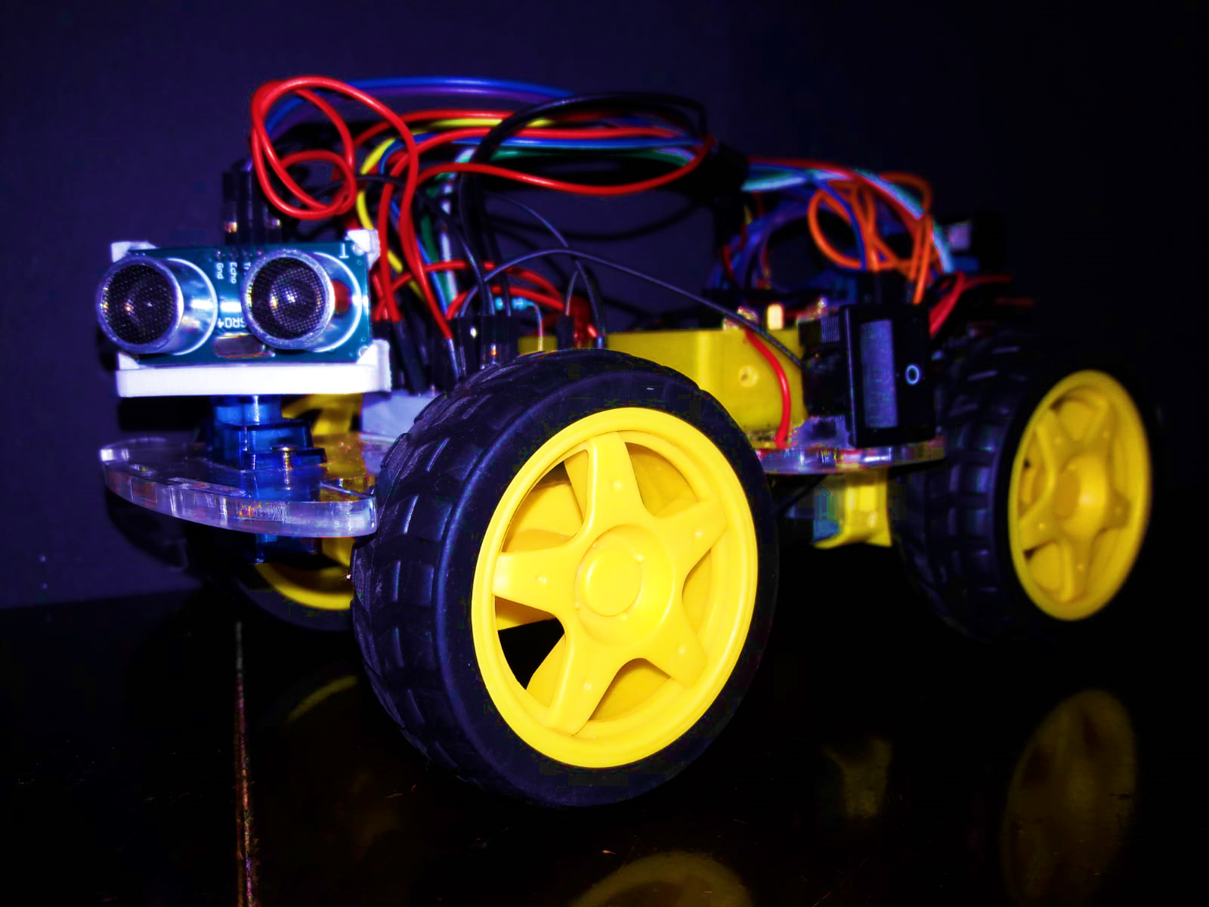Project Description

Jose A. Hernandez

Miami Dade College

IEEE Robotics and Automation Society

Introduction

Purpose

The purpose of this document is to describe the procedures, technology, functioning and tools used for making an Autonomous Toy Car (ATC) as a second prototype (ATC 2). This project is managed by Jose Alberto Hernandez as part of an activity belonging to the IEEE Robotics & Automation Society at Miami Dade College. The Autonomous Toy Car is a project whose purpose is to automate a toy car to allow it to drive by itself without crashing with any object by creating a system that will provide environment and position awareness to the robot based on sensor data (Inertial Measurement Unit, and Ultrasonic Sensor). To accomplish this in an efficient manner this project is divided into three main categories: Hardware (mechanical and structural parts), Electrical (power, motor control circuits, and cable management) and Software (programming the Arduino controller Board). In this document, independent emphasis will be made in each of those three categories for the corresponding prototype and a budget of the project cost will also be included as part of the documentation. Also, future ideas for improvements destined for further documentation will be included at the end of the sections for each category.

Categories Description

The three categories in this project are created in order to facilitate the management and writing process of the project. Each category focuses on a specific aspect of the project as well as the problems encountered in that specific section. As follows it is provided a brief explanation of each category:

**Hardware:** this category or field within the project will focus on the management of the mechanical parts and in the physical structure of the Autonomous Toy Car. This category within the project deals with 3D modeling software like Fusion 360 and drafting software like AutoCAD to make structural parts needed for the project, like for example the chassis of the toy car or any adaptations needed for the electrical components to be attached to the base of the toy car. The goal of this section is to demonstrate the making process of the physical parts of the project.

**Electrical:** this category will focus on describing the design and implementation of circuits to safely control motors, sensors, and other components by connecting these to the Arduino board. This section will cover the libraries used for controlling the sensors attached to the Arduino board by using the Arduino IDE. Also, it provides a schematic of all the connections made between all electrical components in this project. This section is the bridge between hardware and software by establishing an effective control system for the Autonomous Toy Car to be programmed.

**Software:** this last category will focus on describing and explaining the algorithms that will allow the toy car to avoid obstacles using sensor data collected by the Ultrasonic sensor and Inertial Measurement Unit. This section will refer to the actual program written in the Arduino IDE via hyperlink. Most of the autonomy problems are listed in this section since the instructions are given to the Arduino controller board in this section. Also, this section explains several methods used for increasing the accuracy of the data received from the sensors as well as methods to detect and discard false distance data and covers the communication protocol used for the Inertial Measurement Unit (IMU).

Project Purpose and Theory

The Autonomous Toy Car Project aimed to automate a toy car from scratch, using an Arduino Uno R3, an Inertial Measurement Unit (IMU) -which measurers acceleration, magnetism and angles in *x, y, z* axis-, and an Ultrasonic sensor -which measures distance- to sense the environment and control the movement of the vehicle to allow the prototype avoid objects. The purpose of this project was to allow the toy car to autonomously drive without crashing with any object in the way by making smart decisions on where to move based on sensor data.

To accomplish this, the Arduino controller board used an algorithm that allowed it to decide whether an obstacle is too close (40-50 cm or 15.75-19.70 in) to the toy car based on data from the ultrasonic sensor. Then the algorithm decided to make the car turn right or left based on the greatest average distance sensed at each side of the car. To take it even further, the algorithm determined what angle is the best to turn to at either the left or the right side by using a combination of the IMU, ultrasonic sensor, and the angle of the servo motor1. Now, to make this possible, the Arduino board will change the direction of the current into each pair of motors in the right and left sides of the vehicle independently by using a motor driver. That way, when the algorithm decides there is an obstacle considerably close, it will enable the Arduino to stop both motors from working. Then when the program decides where to turn, the Arduino will activate the pair of motors at the opposite side of where the program decided the car should turn to move in the forward direction and the other pair of motors to move in the opposite direction. This will make the toy car rotate towards the desired direction unlike a regular car’s steering system but imitating the turning system of a war tank2.

1 This will be explained in the Software section.

2 Further details in the Hardware and Electrical section.

Specifications

The Autonomous Toy Car Prototype 2 (ATC 2) is a toy sized vehicle consisting of four 3-6 Volt gear motors with plastic wheels attached and a Servo motor (9g) to control the movement of the sensor which are all attached to a plastic base of 227 x 130 mm. It uses an UNO R3 controller board manufactured by Elegoo and a L298N dual bridge motor driver. These four motors along with the UNO R3 board and the L298N motor driver are powered by two 18650 Lithium Ion 3.7 V / 5800 mAh rechargeable batteries connected in series.

This prototype uses an Ultrasonic sensor (HC-SR04) to detect the distance to nearby objects in the surrounding environment. Also, it uses an Internal Measurement Unit (MPU- 92.65) to calculate displacement and angle turned. The four motors are controlled by the UNO R3 board by means of the L298N motor driver. The motor driver used in this project allows for changing the direction of the current flow into the motors as well as the speed of the motors by using the digital pins and Pulse Width Modulation (PWM) pins respectively of the UNO R3 board.

The algorithm used is written in Arduino programming language, or Arduino IDE. Some of the libraries used in the algorithm include the “SR04.h” to control the ultrasonic sensor, “Servo.h” to control the servo motor, and “MPU9250.h” to control the Inertial Measurement Unit. This program uses several “if” conditions which will check whether the car is too close to an obstacle, if it got stuck with something and whether the data read from the ultrasonic sensor is false or unprecise. All these conditions are constantly being checked and if any condition is true at some instant, a specific set of instructions will be executed. Functions for the movement of the toy car like “moveForward,” “moveReverse” and others are made to avoid a lengthy and hard to read program.

Hardware Section

Making the car’s base

The base of the Autonomous Toy Car was first designed using Fusion 360, a 3D modeling software from Autodesk. The base is about 270 by 130 mm, and it includes several holes designed for cable management. This base is where all the components, are going to be attached so it is necessary to for it to be maid out of a resistant but also light material. In this project the car base was laser cut from a 4.30 mm vinyl panel which is a rigid and transparent plastic.

It is very helpful to make a 3D model of the base before it is manufactured because it allows to check if the designed or drawn prototype is of desired size, thig that is very convenient. Also, instead of laser cutting the base from a vinyl panel, this base could be 3D printed using an “stl” file of the base model, a 3D printed version could even make the base lighter thing that is very convenient as well. As a result, a step by step explanation of how the base was designed as a 3D model is provided as follows.

Making a 3D model of the base is very simple, practically it was only needed to draw ¼ of the base, the rest was made using the “Mirror” tool used in Fusion 360. As follows it is showed a dimensioned drawing of ¼ of the base.

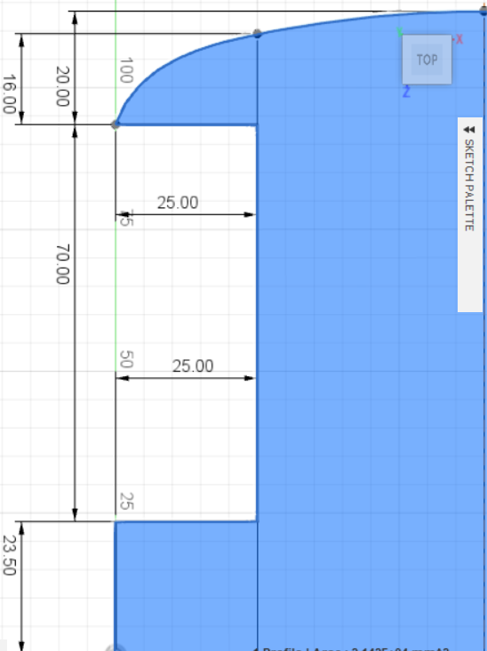

The next step was simply selecting all the lines in this sketch and make a reflection over the line above where it says “Sketch Palette” using the “Mirror” tool. The result was something like this:

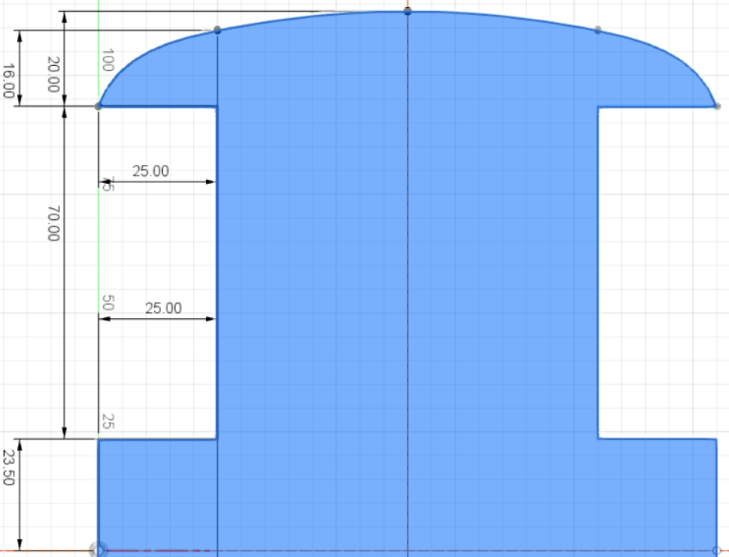

Then, to make the full sketch of the car base is making another reflection of all the lines in the drawing, but now using the dashed line at the right as the mirror line, and the result will be something like this:

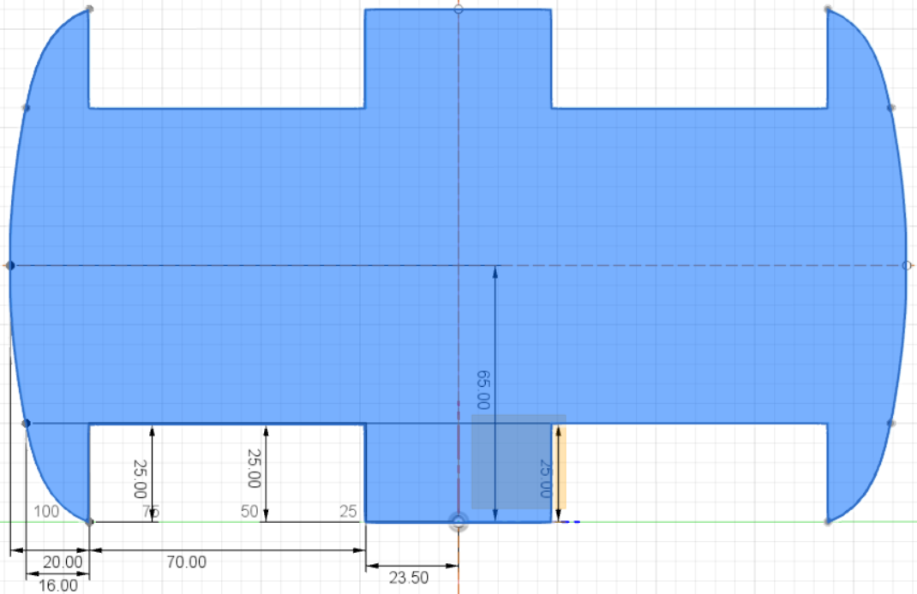

Finally, the last step needed is to rise the selected (blue) area into a 3D body. This is done with a tool called “Extrude” in Fusion 360. To access it, first the area to be extruded is selected and under the “Solid” menu, the option “Extrude” is selected, as the following picture shows:

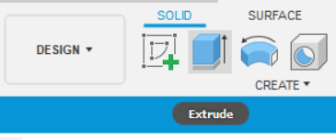

Then it is defined the high to extrude the selected area in the Extrude tool menu, in the case of this project the high or thickness of the base was defined to be 3 mm, to keep it as light as possible in case it is 3D printed. Now the base is a 3D model as the following picture shows, and it could be 3D printed. Also, for safety reasons and to save material, the sharp corners of this base are smoothened by using a tool called “Fillet”. To fillet those corners, first select the option “Fillet” under the “Solid” menu, then select the corners to fillet, and finally input the radius of the fillet in the Fillet tool menu. In this project the fillet for the center piece was 14 mm and the filet for the border of the bumpers was 3.5 mm. The result was something like this:

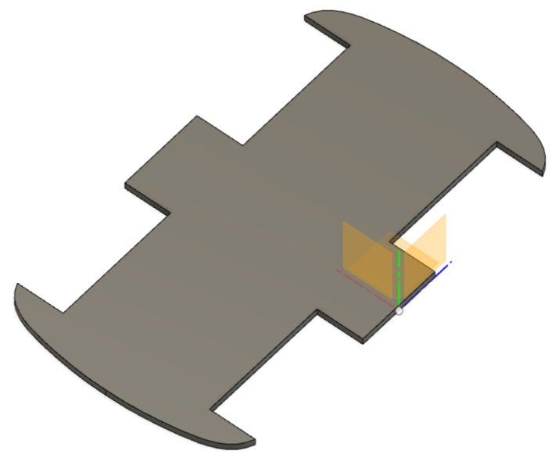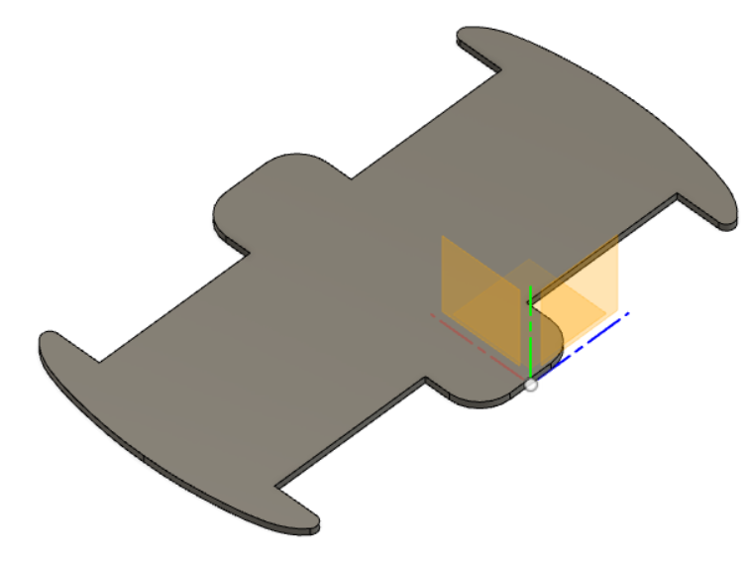

However, to the base of this project were also included some extra features that allow for cable management and the attachment of bumpers if desired. Also, in order to hold the servo to the base there were made specific holes according to the dimensions of the servo motor. As follows it would be made a brief explanation of how to make such useful features for the car base step by step.

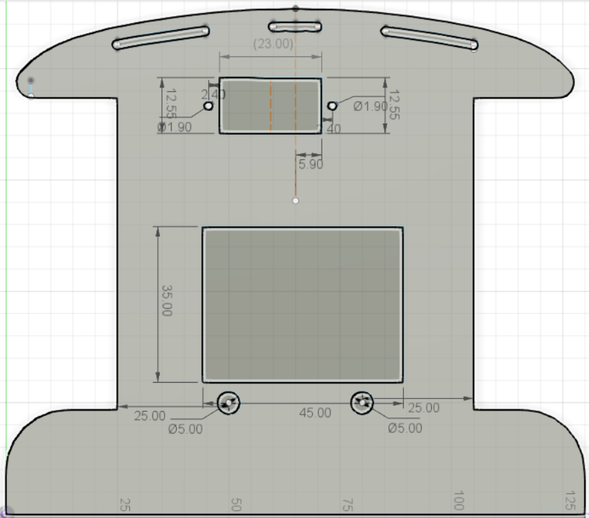To the created base model, it was added a sketch on the top surface of the model by clicking the surface and then selecting the “Create Sketch” option under the “Solid” menu. Then on top of this surface several features were drawn as it is shown on the following picture:

To explain, in this picture, the drawings are made on what is the front part of the base of toy car. The sketch for the bumper holes is the one closest to the front border of the base, this feature does not have any visual dimensions since it is dependent on the front border. These holes were made by creating a first offset of the front border of the bumper 3.00 mm into the base, and a second offset 5.00 mm into the base. The resulting space between the offsets which is 2.00 mm is the width of the bumper holes, then the offsets were modified to have just those three sketches along the front border and to make the borders round using the arc tool in the drawing menu.

Also, below the bumper holes it is found the holes for inserting the servo. These holes are very well dimensioned otherwise it will not be possible to attach the servo. As it could be appreciated the rectangle corresponding to the servo hole is not perfectly centered with the center of the base (two vertical dashed lines), this is because the rotor of the servo motor is located 5.90 mm away from the right border of the servo, and thus what was wanted to be centered is the rotor so that when the ultrasonic sensor is placed on top of the servo rotor, it is centered with respect to the car base. Also, the holes to screw the servo to the base are 2.40 mm away from each side of the servo hole and are 1.90 mm in diameter. For clarification purposes, as follows it is attached a picture showing the dimensions for the Servo motor 9g (SG90).

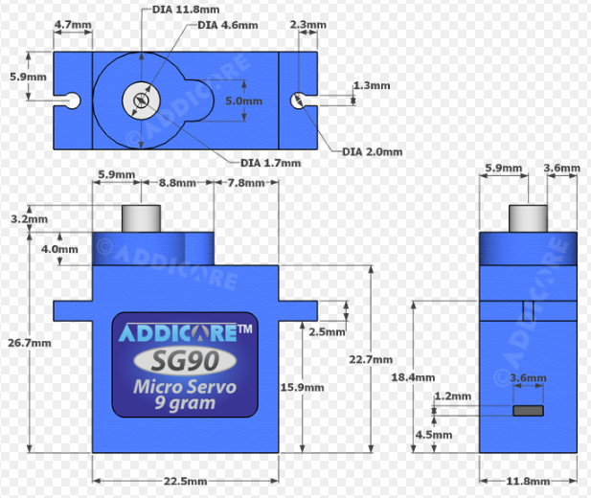

Finally, the big square in the center of the drawing is simply a 2D representation of the area that will be occupied by a small bread board which will be covered in the Electrical Section of this report. Also, the two holes on the very bottom which are 5mm in diameter were made with cable management purposes.

After those sketches were made on the front half of the base, it was used the “Mirror” tool once again to have some of those sketches like the bumper holes and the 5.00 mm cable management holes also in the back half of the base, using the dark like at the very bottom of the drawing as the mirror line. The result is shown on the picture at the top. Then after all the sketches were created, the next step was to use the “Extrude” option, but this time not to create a 3D profile but to subtract the selected area from the created sketches from the 3D profile of the base, thus creating a hole. To accomplish this, first the area inside the sketches was selected and then, the “Extrude” tool was selected, and in the “Extrude” tool menu the “Extent” option is changed to “To object”, finally it was selected the bottom of the base 3D profile and the result is a cut as shown in the picture at the bottom, as follows.

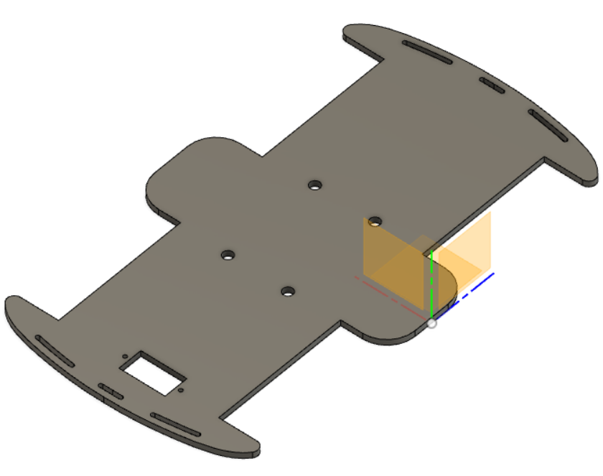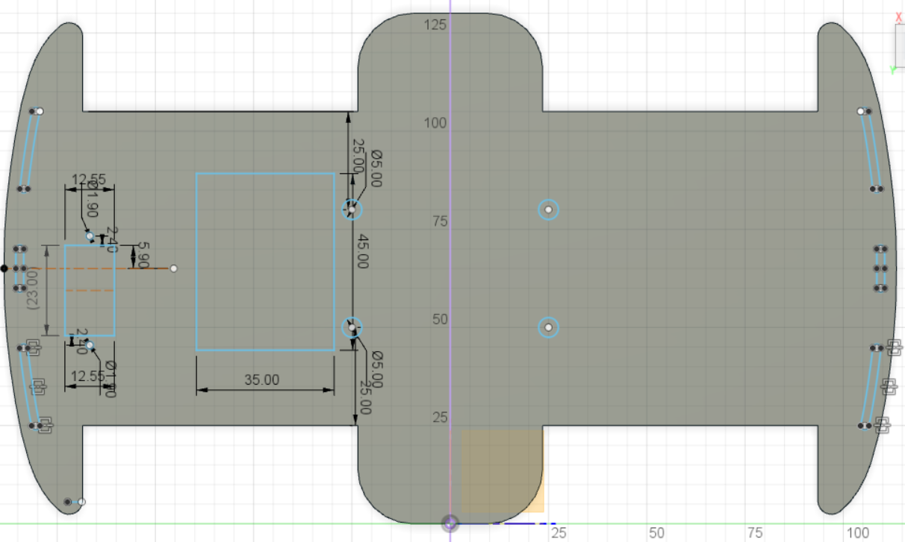

Also, repeating the exact same procedure, other features were added, especially destined towards cable management and to attach the UNO R3 board to the base as it is shown in the following set of pictures. The picture at the left depicts the drawing and dimensions and the drawing at the right depicts the actual 3D model after the modifications, as follows.

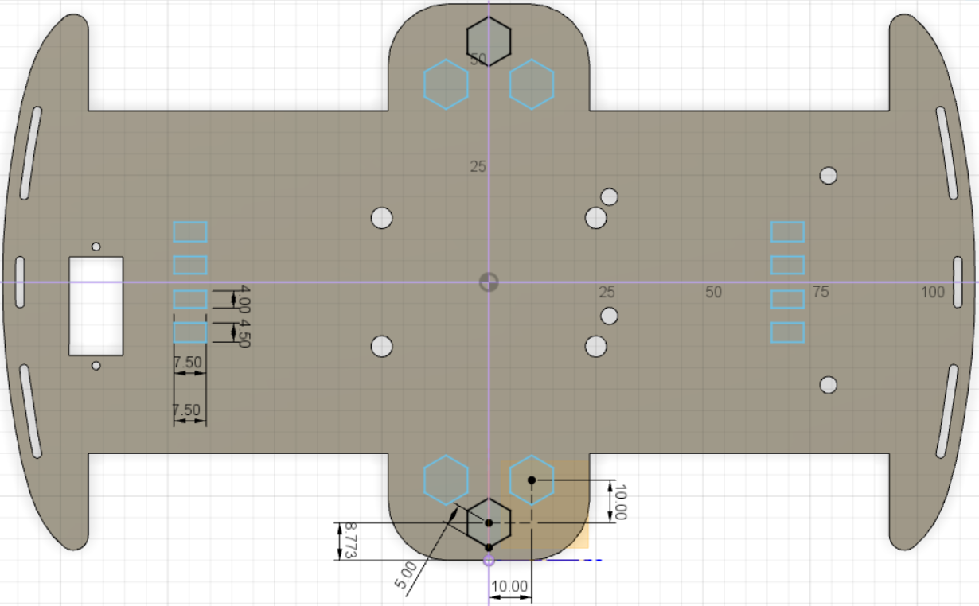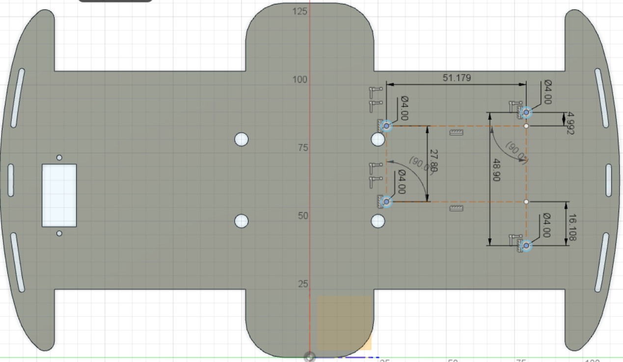This photo depicts the dimesions for the position of the sektch for the four holes that hold the UNO R3 board to the base.

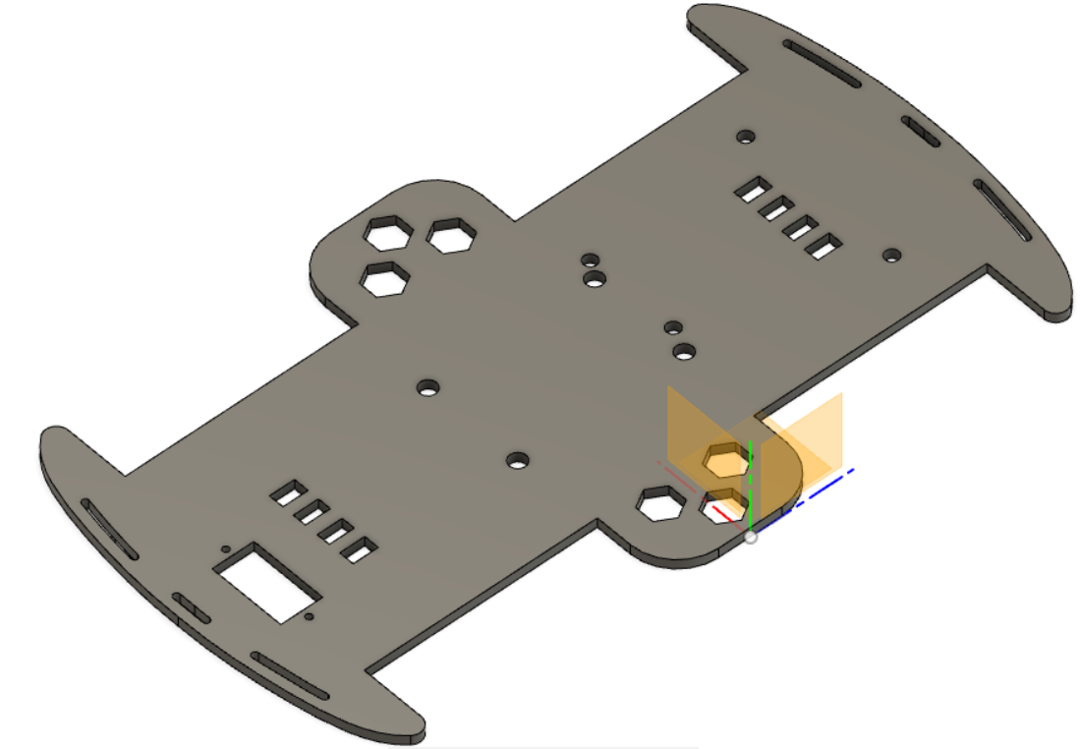This second picture depicts the holes for holding the UNO R3 board already made in the base. Also it depicts the sketches for extra features intended for cable management like the hexagons and the small rectangles along with its corresponding dimensions. Notice, those elements that do not have any dimensions are the product of a refection using the “Mirror” feature or simply a copy of the original feature, like the hexagons for example.

This last picture shows the final look of the car base with all the features included.

With regards to the manufacturing of this base, the car base for this project was made using a laser machine. A vinyl panel of 4.30 mm thick was cut using the laser machine, having as reference only the sketches made for this base design as a “dxf” file. To obtain this type of file the sketch belonging to the base were first selected in Fusion 360, then it was right clicked, and the option “save as DXF” was selected. This type of file is user to laser print of laser cut. In case the base were to be 3D printed, the body of the base (the 3D model) would be first selected by clicking the object on the browser menu, then it is right clicked and the option “save as STL” is selected. This type of file is the one generally used for 3D printing.

Wiring the motors

Wiring the motors may seem simple, however, there is some thought behind it. The objective in correct motor wiring was to connect all four motors in a parallel circuit and make these rotate in the same direction (front), so that the car moves forward when the motors are applied current. Now, to make all motors rotate in the same direction it is helpful to consider that since the motors are opposing each other the direction of their spin is going to be also opposite. So, to make them rotate in the same direction, the following steps were followed:

1. 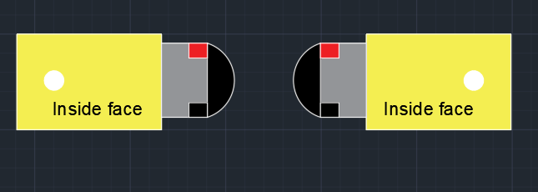Motors were placed with the terminals facing each other. As the picture shows:

The red and black rectangles are the labels for the positive and negative terminals of the motors. By the way these motors are 3-6 Volt gear motors, the motor itself is the gray and black areas and the gears are contained inside the yellow box. These gears greatly reduce the speed of the motors but increase the torque or force of each spin.

1. Then the wires were placed by connecting the positive terminal of one motor (red rectangle) with the negative terminal of the other motor (black box) using soldering iron. Simply diagonally connecting the contacts of the motors, as the following picture shows:

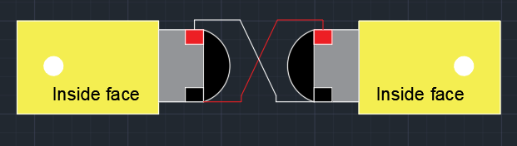

When the contacts of the motors were connected in diagonal, this allowed both motors to spin in the same direction when these are given current. This is a useful property of DC (direct current) motors.

1. By applying steps 1 and 2 it was solved the problem of making both motors rotate in the same direction. However, there was another problem with regards to the movement of the motors and this one has to do with electricity. If a battery is connected to one of the motors only and expect the other to move, it could be seen that the other motor would move in the same direction but slowly or it may not move at all. This is because the connections of the motors are in series, this means that the voltage received by the second motor will be less than the voltage received by the first, and the less voltage the poorest the speed of the motor. So, to solve this both motors were connected in parallel so that voltage doesn’t get affected, further details about this will be covered in the Electrical section of this report. The following picture shows the parallel circuit made and the actual 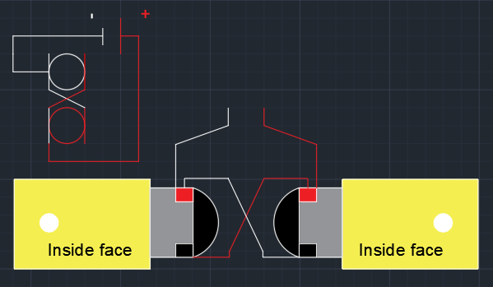representation:

To make these connections it is recommend that the cables are welded to the motors using soldering iorn, this will guarantee that the connection is safe and reliable.

Gluing DC gear motors and Servo motor

Gluing the motors to the car base, is an easy but important task. The important aspect while gluing the motors to the base is to consider that all four motors should be vertically and horizontally aligned as good as possible. If all four motors are not correctly aligned this may cause the toy car to deviate to one of the sides. The process started by sanding the surface area that will be glued (gear motor box and vinyl base) with 600 – 800 grain sandpaper, this guarantees that both surfaces provide enough grip for the glue to paste effectively on both surfaces. Finally, it should be considered that the positive and negative contacts of the motors are all facing the inside. So, the following steps to glue the motors were used.

1. First, sandpaper was used to slightly sand the area in the motor base where the motors were going to be glued along with the faces of the motors which will be glued to the base. Then, after sanding all surfaces, the excess of material or dust from the sanding was removed using a clean and dry piece of fabric.
2. Then, to make sure the motors are aligned vertically it was used a ruler as the following steps cover.
3. First it was measured the width of the face of the gear box that will be glued to the vinyl base, which is about 20.00 mm (2.00 cm in the drawing).
4. 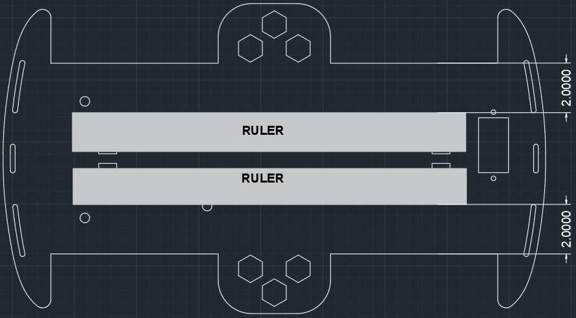Then, it was made a mark 20.00 mm (2.00 cm in the drawing) from the border of the vinyl base in, this indicated where the rulers needed to be placed.
5. Finally, the ruler is positioned to coincide with the marks made, the ruler was held in that position by slightly gluing it with hot glue to the base. Then, both motors were leaned to the ruler to achieve vertical alignment.

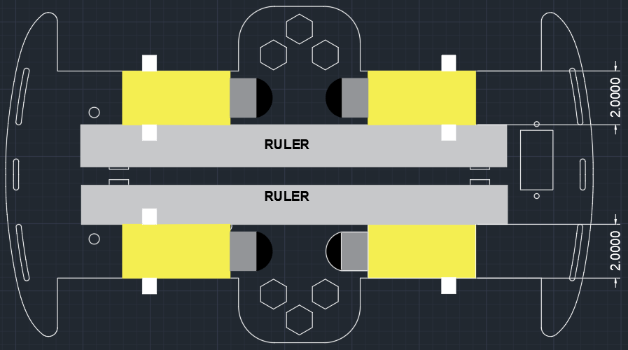

1. After the motors were aligned, then these were glued to the base, using hot glue. First, it was placed a considerable amount of hot glue on the base, and as quick as possible it was placed the gear motors on the hot glue making sure it is aligned with the ruler, then each motor was held tight against the base for around 1 minute.

After the gear motors were correctly glued to the base, it was proceeded with attaching the Servo motor to the base. Differently from the gear motors the Servo motor is attached to the base using screws instead of hot glue. The screws used are preferable 2.00 mm in diameter or M2 and about 4.00 mm in length, the part number of these screws in McMaster-Carr is 94017A101. The 2.00 mm screws entered a little tight in the 1.90 mm holes, but this guarantees a rigid attachment of the servo motor to the base. The rotor of the Servo motor was positioned with the rotor centered with respect to the base as it was previously mentioned and planned in the design process of the base. Also, there was a little inconvenient while attaching the servo and it is the fact that the servo motor entered almost perfectly into its corresponding place in the base, this is good, however it also has a cable coming out from one of the sides that need as well to go through the rectangular hole. As a result, to avoid forcing the power cables and thus damaging them, it was needed to unscrew the four small screws at the bottom of the motor to open the bottom part of the plastic Servo box, then the cables were passed first as these are now hanging from the bottom of the servo not the side. After everything was in the correct position, the bottom of the Servo motor was screwed back again, and the 2.00 mm screws were screwed on place to hold the motor tight to the vinyl base. The following pictures depicts the positioning of the servo.

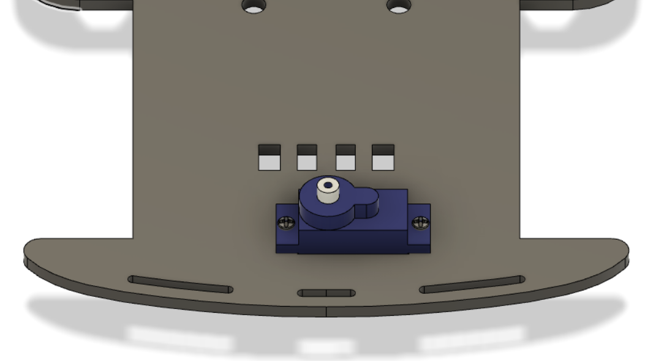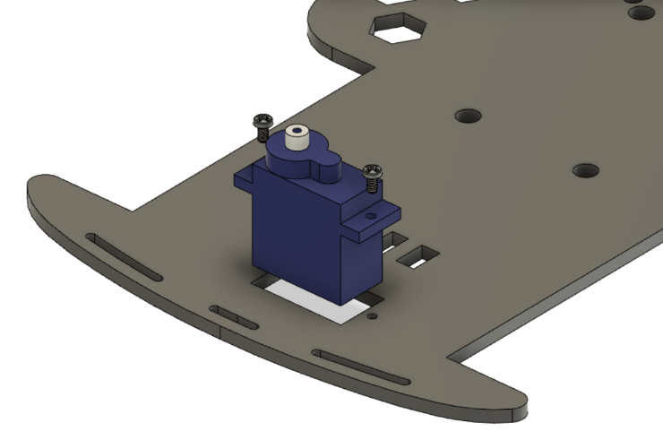

Attaching Ultrasonic Sensor

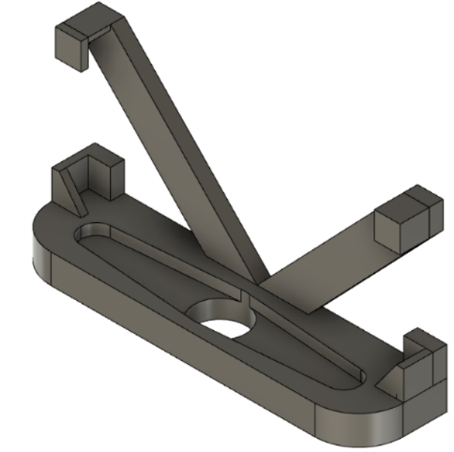The ultrasonic sensor goes attached to the rotor of the Servo motor, this way when the motor is given instructions in the angle to turn, the sensor moves along with the rotor of the motor, more about giving instructions to the servo will be covered in the Software section. Now, to attach the ultrasonic sensor to the servo motor it was needed to create a special piece to connect both components. This piece was downloaded from an online source as an “stl” file ready to 3D print, but it could as well be 3D modeled using Fusion 360, as the following image shows.

This image depicts the piece needed in order to attach the ultrasonic sensor to the servo motor. This piece is ready to be 3D printed. Further details on how this piece was designed is not cover in this report to reduce its length. However, this model could be found online [here](https://www.thingiverse.com/thing:595454/files). This online model was the one used in this project.

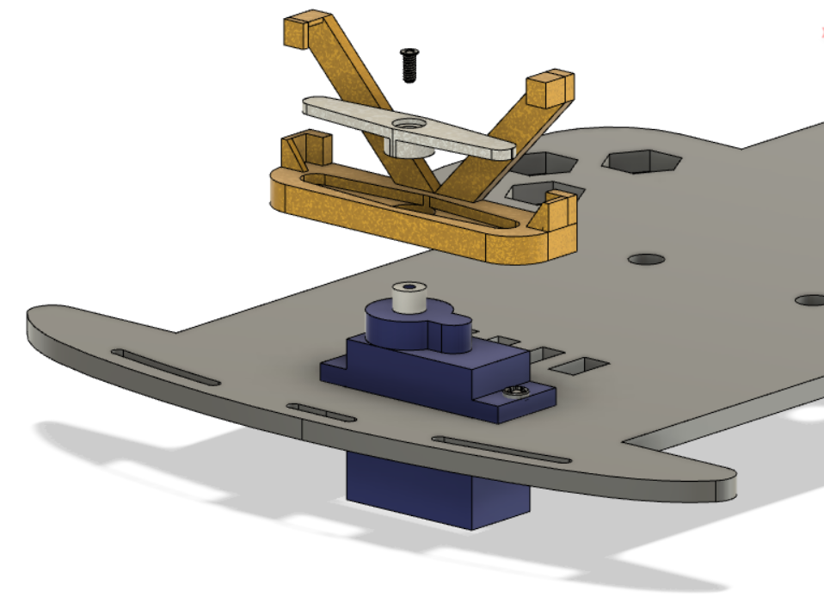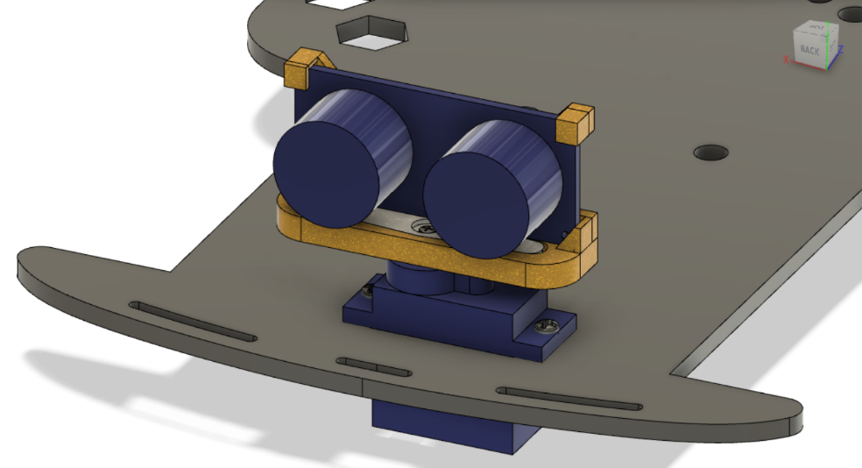Then, in order to mount the ultrasonic sensor using the 3D part previously show it was needed a 1.70 mm (M 1.7) screw about 4.00 mm in length, this item’s number is 96773A637 in McMaster-Carr (*Note: the head of this screw from McMaster-Carr is too small, it would be preferable a screw with a head diameter greater than 2.50 mm but smaller than 4.60 mm). As follows a picture is shown depicting the assembly of the servo and the ultrasonic sensor.

The picture at the left showd the order of assembly and the picture ath right shows the ultrasonic sensor assembled along with the rest of the pieces and attached to the servo motor.

Attaching the UNO R3 board

The UNO R3 board was attached to the board using metric 18-8 Stainless Steel Coupling Nuts, the part number for this item is 93590A103 in McMaster-Carr with a 3.00 mm screw diameter and 9.00 mm length for the coupling nuts. Only two of these coupling nuts were used in this project since the hole closest to the reset buttom of the UNO R3 board is too close to other components making it very difficult for a screw to be inserted. So, for this hole it was used a Male-Female Threaded Hex Standoffs, the part number for this item is 93655A419 in McMaster-Carr, the dimesnsions for this item are 3.00 mm for the screw diameter and 8.00 mm for the length of the nut. This feature does need to be leveled with the rest which are 9.00 mm, its purpose is to provide suport for everytime the power cable or USB is connected and disconnected, so the UNO board stays firm. Also the two coupling nuts will hold the UNO board tight to the base, so the third feature doesn't necessarily need to have a screw to hold the base. The fourth hole for the UNO board on the base is blocked by the motor which was glued underneath because of a wrong placement of the hole, so this fourth hole is not used. These three coupling nuts were attached to the base using 3.00 mm screws 6.00 mm in length as the first picture below shows, the part number for this items is 94102A102 in McMaster-Carr. Then, after the coupling nuts were screwed tight to the base the UNO board was inserted on top and attached using two screws of the same type (94102A102) as depicted by the second picture bellow.

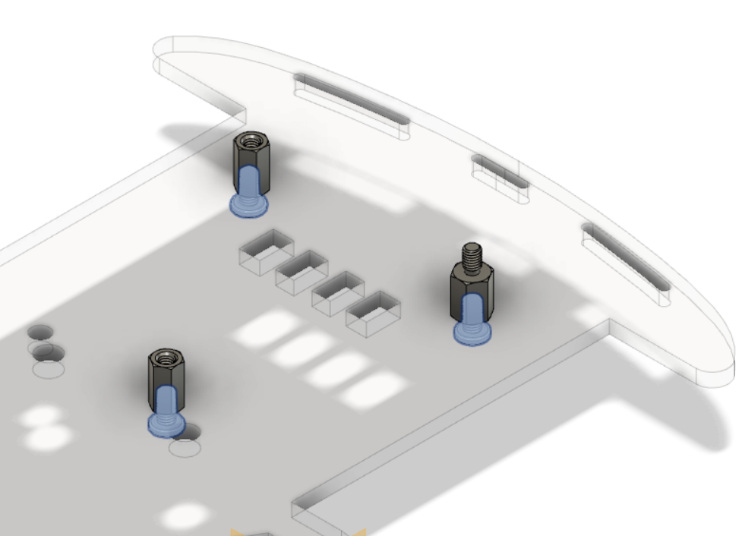

This picture depicts the attachment of the coupling nuts to the back section of the base using the highlighted M3 screws.

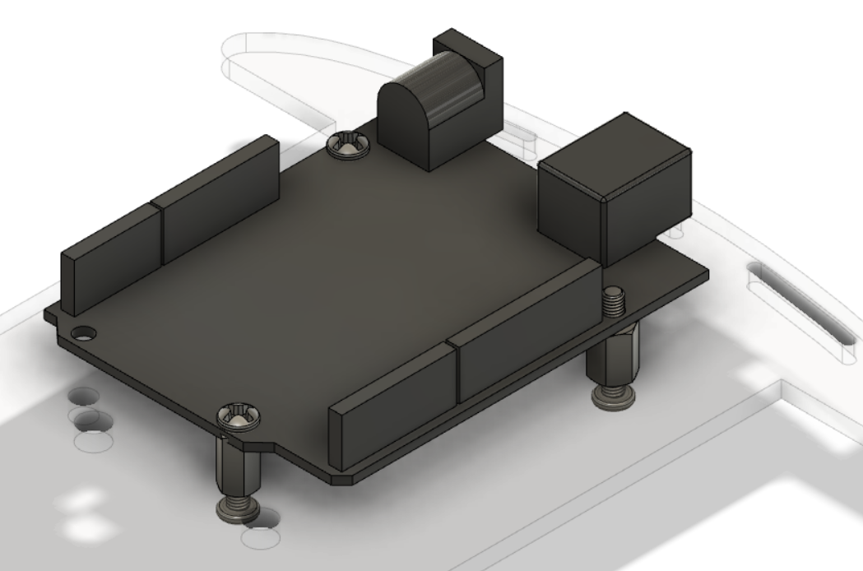

This second picture shows the assembly of the UNO R3 board on the coupling nuts.

Battery Holder Design

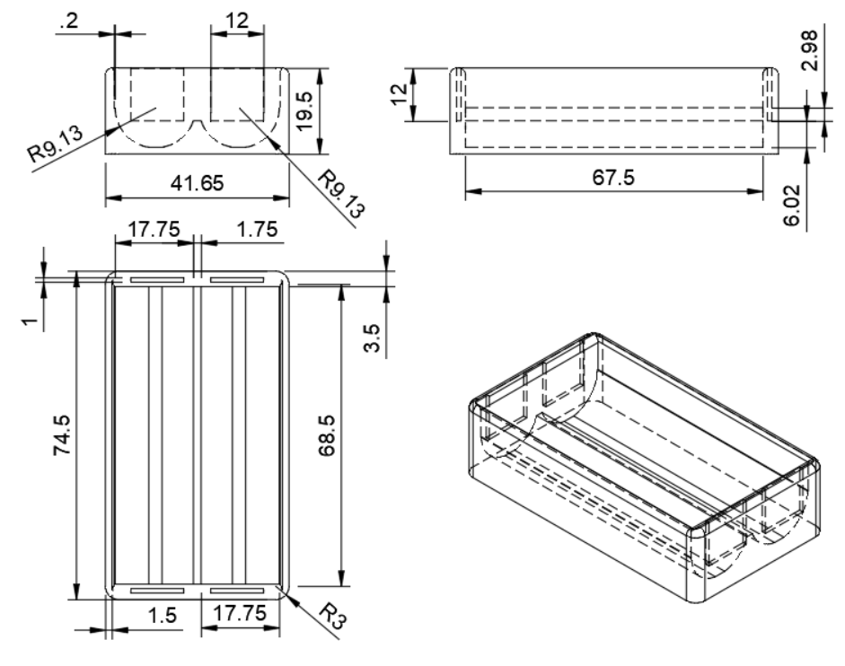Since the batteries used for this design are not very commonly used in daily life, it was needed an especial holder for these batteries. Bellow it is provided a drawing with specifications on the dimensions for this battery holder.

After the 3D model of the battery holder was made, it was needed to make holes at the upper and lower parts of where terminals of batteries were placed. This was done to so that the batteries contact thin metal plates inserted in the squared 12x12 mm holes at each end of the battery holder.

Motor Driver Adapter

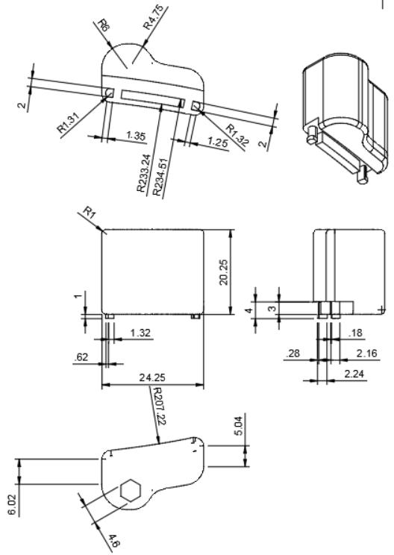Like the batteries, the motor driver needed an especial part in order to be attached to the car prototype. Tanks to my cousin Miguel Hernandez (Biomedical Engineer), he designed a printed this specific part to adapt the motor driver to the base. Below it is provided the drawing with specifications on the part made.

Notice, the base of this parts goes attached to the bumpers holed of the base. Then on top op it goes inserted in the hexagonal hole a 16.00 mm female coupling nut 4.60 mm in diameter.

Turning System Explanation

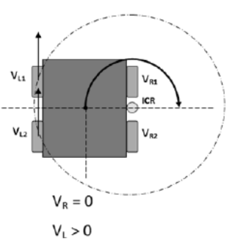When an obstacle is detected, the vehicle should be able to avoid it, so the vehicle should turn. Now, the turning system of the Auto Toy Car has no steering system like regular cars, instead it imitates the way war tanks turn. To accomplish this, only one pair of motors either at the right or at the left will be shut on, while the other pair of motors will turn in the opposite direction. For example, if the algorithm decides to turn right, the pair of motors at the left will be given power to move forward, and the motors at the right will be given power so that these rotate in the opposite direction than the left motors. The result of this turning system should be a turn around the center of the car base, which was not the actual result in the prototype due to irregular manufacture of the plastic wheels and tires used in this project, besides uneven weight distribution on the prototype.

Budget

Hardware section budget:

|  |  |
| --- | --- |
| ITEM | COST |
| Gear motors x4 + Wheels x4 | ~$12 (Amazon) |
| Servo motor 9g | ~$5 (Amazon) |
| Ultrasonic Sensor | ~$5 (Ebay) |
| Arduino holders x3 + screws + 3D parts | Free (MDC Makers Lab) |
| Hot glue + Cables + Iron soldering | Free (MDC Makers Lab) |
| TOTAL | $24.00 |

*Note: the prices listed include shipping costs.

Especial thanks to Miami Dade College Makers Lab at Wolfson Campus for allowing the different parts of this project to be 3D printed and laser cut at no cost.

Finalized look

After all the hardware modifications were done, the result was something like the following picture shows. Notice, the car base’s opacity has been reduced to %60 and the wheels were inserted to the rotor of each gear motor, and the battery holder was placed towards the center of the car base.

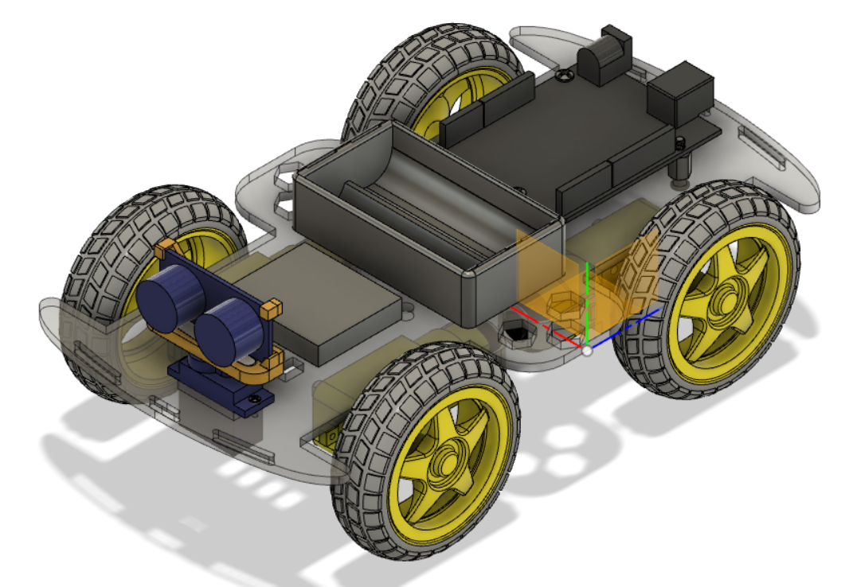

Notice, the picture above does not have included the motor driver along with its corresponding attachment. The actual look of the Autonomous Toy Car is provided as follows.

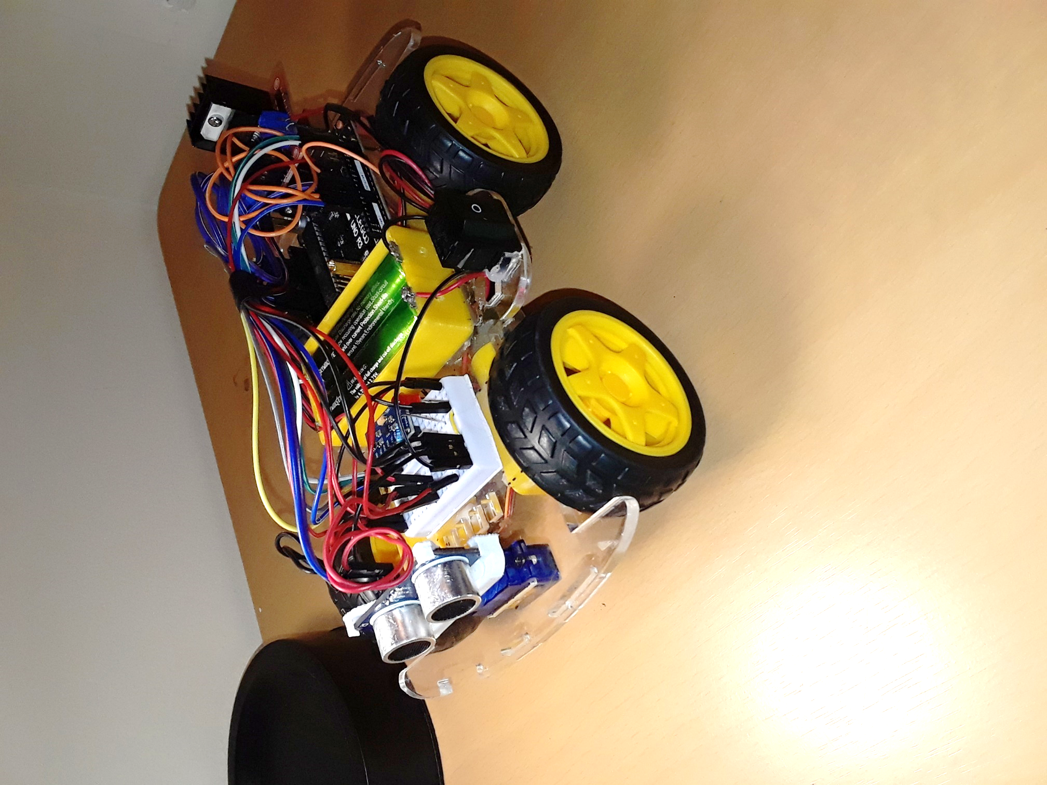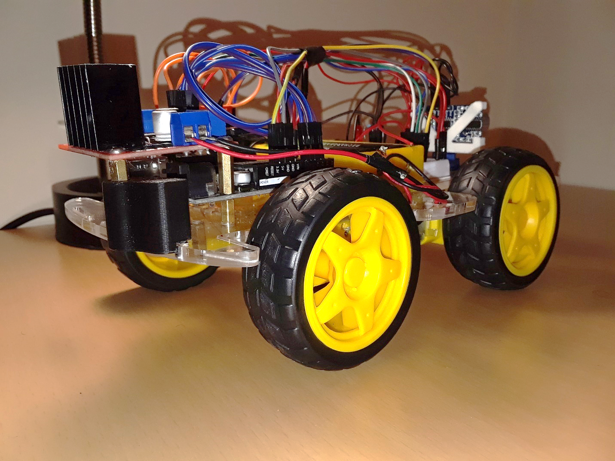

Electrical Section

Electrical Components and Specifications

Lithium ion batteries:

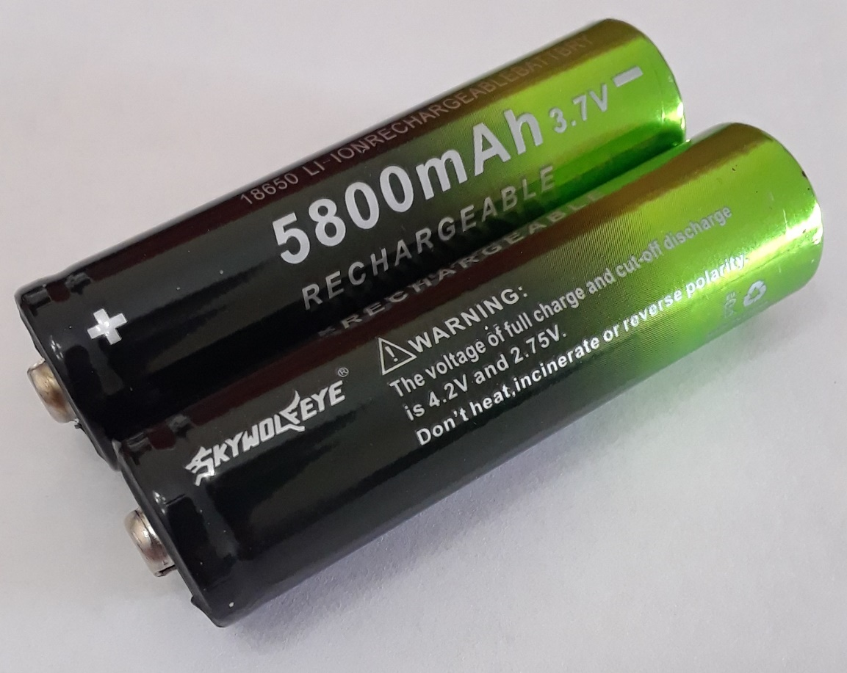The batteries used for this project are 3.7 V 5800 mAh rechargeable 18650 Lithium ion batteries of the brand Skywolfeye. The full charge voltage of this battery is around 4.20 V and the cut-off discharge voltage is around 2.75 V. The weight of this battery is 43.3 grams times two batteries used in this project, 86.6 grams correspond to the weight of the batteries. The dimensions of this battery are 67.40 mm in length and 18.20 mm in diameter. Below it is provided a picture of the batteries used for documentation purposes.

UNO R3 controller board:

The UNO R3 board used in this project is a microcontroller board based on the ATmega328. It has 14 digital input/output pins from which 6 can also be used as PWM outputs. The operating voltage of this board is 5V, and the recommended input Voltage ranges from 7 – 12 V, the limits for the input voltage are 6V (minimum) and 20V (maximum). The DC current for every input/ output pin is 40 mA and the DC current through the 3.3V pin is 50 mA. The flash memory of this device is 32 KB and the clock speed is 16 MHz. This board also has 6 analog inputs labeled from A0 through A5, from which pin A4 is also an SDA pin and A5 is an SCL pin. Also, a default SDA and SCL pins are available independently after the AREF pin, these two pins support TWI communication using the “Wire” library which is used in this project for stablishing communication with the IMU. Further details on the use of these pins will be provided on the Software section of this report. The dimensions of this board are 8.13 x 6.10 x 1.02 mm.

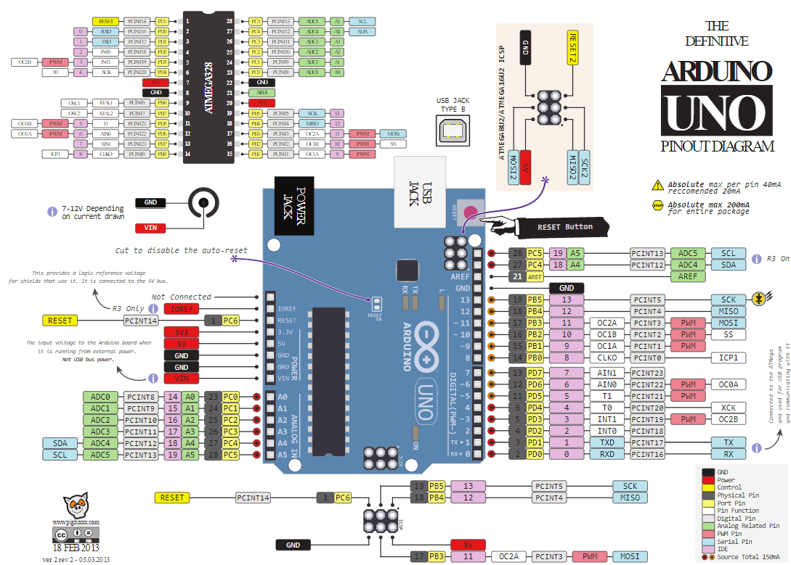The PWM pins in this board are pins 3, 5, 6, 9, 10 and 11. In this project pins 5 and 6 were used to control the speed of the left and right motors respectively. Also pins A0 and A2 or 14 and 16 were used to control the forward movement of the right and left motor respectively while pins A1 and A3 or 15 and 17 were used to control the reverse movement of the right and left motors respectively. The PWM pin number 9 is used to control the movement of the servo motor and pins 12 and 4 are used to control an LED and an active buzzer respectively. Further details on the schematic for all connections is covered on the “Circuit Schematic and Cable Management” section, also the pins used for the sensors are specified on each sensor’s section. As follows a picture of the UNO R3 board with pin labels is provided for clarification purposes.

The picture above depicts an Arduino UNO board which is very similar to the board used for this project.

Ultrasonic sensor

The HC-SR04 is the distance sensor module used in this project to measure distance and detect obstacles, it uses ultrasonic waves to measure distance accurately from a range of 2.00 cm to 400 cm or 4 meters. For optimal obstacle detection, the obstacle should be larger than 0.5 m2, and thus the near the object the smaller it may be for optimal detection. The operating voltage of this module is 5V DC, the operating current is 15 mA, and the operating frequency is 40KHz. The basic functioning principle of this module is simply based on timing how long it takes the ultrasonic wave (sound wave) to return or its propagation velocity. To accomplish this, a 10 microseconds high pulse is applied through “Trigger” (Trig) pin, this makes the module to send eight 40KHz acoustic bursts and start the timer which will measure the time it takes the sound waves are received by the module’s receiver. The time the sound waves travel in the air or the ultrasonic propagation time can then be used to calculate the distance to the closest object detected. This is done using the following formula, in which *D* is distance, *C* is the velocity of sound, and *T* is the propagation time:

*D = CT*

*For C = ~ 343 m/s at 20 °C*

*Notice: C is dependent on temperature, for optimal results consider temperature for the value of C in this calculation.*

This previous operation was performed using a library called “SR04.h” made by Elegoo Corporation, more details regarding the use of the library will be covered in the Software section along with some of the difficulties while using this sensor module. With regards to the pinning of this component to the UNO R3 board, pins 7 and 8 were used to connect the “Trig” and “Echo” pins in the HC-SR04 sensor module respectively while the VCC pin and GND pin of the sensor were connected to the common 5V DC source and GND (ground) terminal for most components in the circuit which is located on a small breadboard used for this project. The dimensions of this module are 46.0 x 20.63 x 15.87 mm. A picture of the sensor module is depicted below for documentation and clarification purposes.

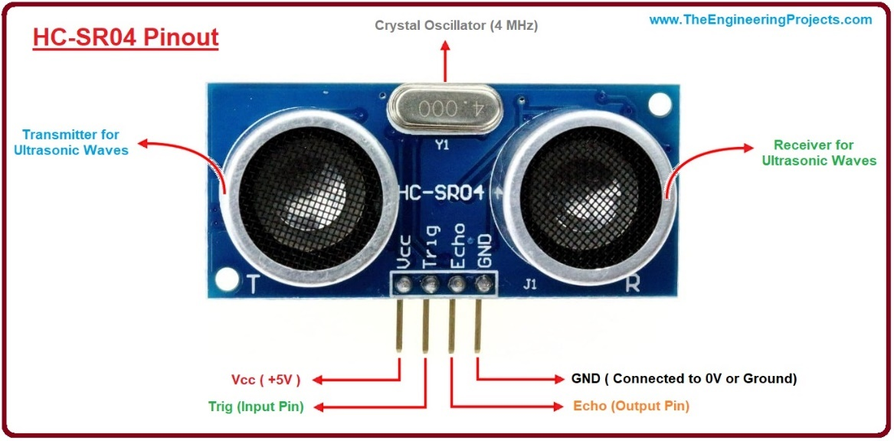

IMU 92.65 sensor

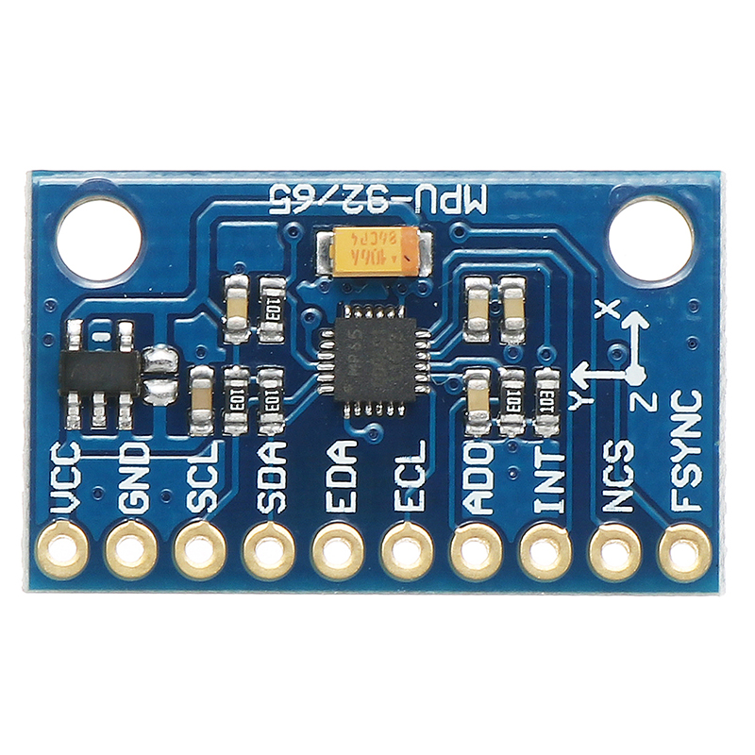The IMU (Inertial Measurement Unit) MPU 92.65 is the sensor used for measuring the position of the toy car in the space (3-axis), especially the angle which it turns in this project. This sensor can measure acceleration in the user set ranges of ± 2 ± 4 ± 8 ± 16 g, it also has a gyroscope which measures the user set ranges of ± 250 500 1000 2000 ° / s, also it can measure the magnetic field of Earth in the range of ± 4800uT. The range used in this project for the gyroscope is 500 ° / s. The output data rate for the gyroscope and accelerometer is 8 KHz and 4 KHz respectively. The operating voltage of this sensor module is 3 – 5V DC, preferable 3.3V DC directly from the UNO R3 board as done in this project. There are 10 pins in this sensor module from which only 4 were used in this project, VCC, GND, SCL and SDA. The VCC pin in the sensor is connected to the 3.3V pin in the UNO board, while the GND pin is connected to the GND (Ground) pin directly in the Uno board as well. The SCL and SDA pins which are for communication are connected to the corresponding SCL and SDA pins in the UNO board. To communicate with this sensor, it was used a library called “MPU9250.h” made by Brian R. Taylor at Bolder Flight Systems in 2017. This library allows to get the information from the sensor, like the acceleration and ° / s, which are then used in the algorithm of the toy car. The dimensions for this sensor module are 25 x 15 x 3.5 mm. A picture of the sensor module is depicted below for documentation and clarification purposes.

L298N motor driver

L298N is an H-bridge motor driver module made to control two DC motors. The drive voltage for this motor driver ranges from 5-35V DC and the maximum drive current is 2A. There are two different power inputs in this motor driver, one is for voltage input in between the ranges of 5 – 12V- which is used in this project since the maximum power provided by the Li-Ion batteries does not exceed 8.40V- and another power input for voltages in the rage from 12 – 35V. One of the best features offered by this module besides of course controlling the movement of the motors is the control of the speeds for each set of motors independently by means of PWM pins on the UNO R3 board. With regards to the pinning of this module with the Arduino board, pins 5 and 6 of the UNO board are connected ENB and ENA pins on the motor driver, these are used to control the speed of the left and right motors respectively. Also pins A0 and A2 or 14 and 16 were connected to IN2 and IN3 in the motors driver to control the forward movement of the right and left motor respectively while pins A1 and A3 or 15 and 17 were connected to IN1 and IN4 to control the reverse movement of the right and left motors respectively. In the section on “Circuit Schematic and Cable Management” a diagram depicting the previously mentioned connections is provided for clarification and documentation purposes. Furthermore, the dimensions of this component are 43 x 43 x 26 mm and its weight is 26 grams. A picture of this 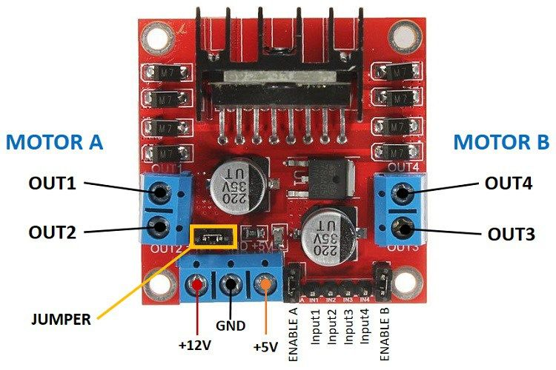motor driver is provided below for documentation purposes.

Servo motor 9g:

Micro Servo 9g SG90 is the servo motor used for this project. The voltage of operation of this motor ranges from 4.8 – 6V and a maximum operational current of 500 mA. The speed of this servo motor is 0.080 sec/ 60°. With regards to the pining of this motor to the UNO board, the power (red cable) and ground (brown cable) pins were connected to the common 5V DC source and GND (ground) terminal for most components in the circuit which is located on a small breadboard used for this project while the third pin on the servo motor (usually a yellow cable) was connected to PWM pin 9 on the UNO board. With regards to the dimensions of this component, these are given in a picture in the Hardware section on “Making the car’s base,” the weight of this component is 9 grams. Below is provided an actual picture of the motor for documentation purposes.

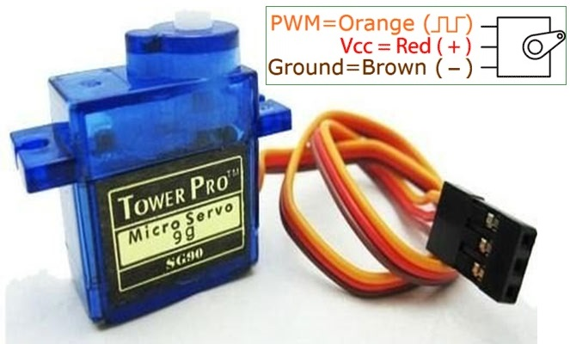

Gear motors:

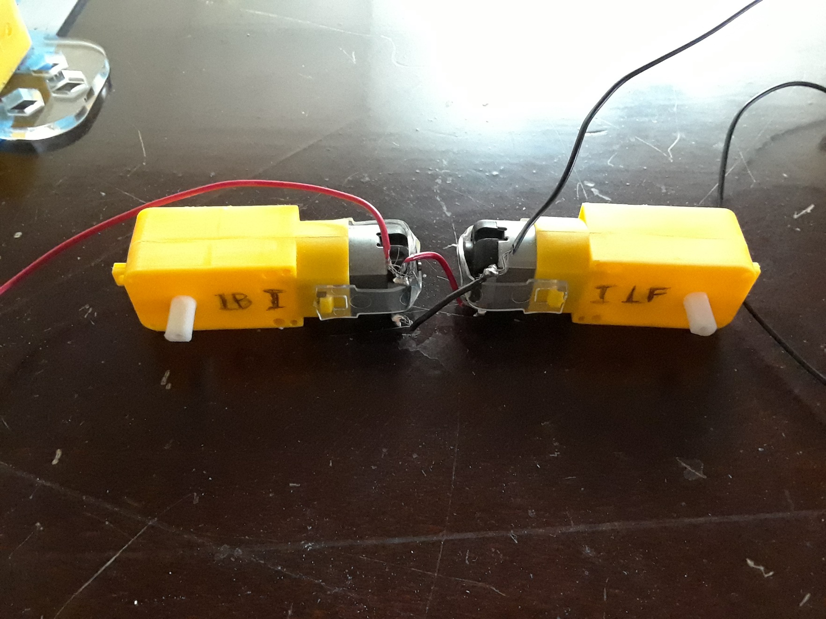The motors used for moving the car are four 3 – 6V DC gear motors which use 150 mA of current and have a torque of 0.15 Nm – 0.60 Nm. With regards to the connection of these four motors, these are connected one to the other in pairs and in a parallel circuit. Then each pair of motors were connected independently at each power output in the motor driver, more details on this connection are provided on the “Circuit Schematic and Cable Management” section. The dimensions of this component are 70 x 22 x 18 mm and the weight of an individual gear motor is 29 grams times four and ~116 grams on this project belong to the weight of the motors. Below is provided an actual picture of the gear motors depicting for documentation and clarification purposes.

Power System

The power system for this project was based on two Lithium Ion 3.7V 5800 mAh batteries connected in series to provide a maximum of ~8.4V if fully charged as the main power source. The negative terminal of these pair of batteries connected in series is connected to a switch and from the switch it is connected to the common GND (ground) terminal in the breadboard, where several components like the UNO R3 board and the L298N motor driver are connected. To the positive terminal of the main power source is connected the UNO board through the VIN pin along with the motor driver. The UNO board serves also as a second power source with independent 5V and 3.3V power source pins. The 5V pin is used to power the ultrasonic sensor and the servo motor since these work with 5V, while the 3.3V pin is exclusively used to power the MPU 9265 sensor (Inertial Measurement Unit). The gear motors as previously mentioned are powered through the motor driver with a voltage of about 4 – 5V depending on the Voltage delivered by the batteries.

Circuit Schematic and Cable Management

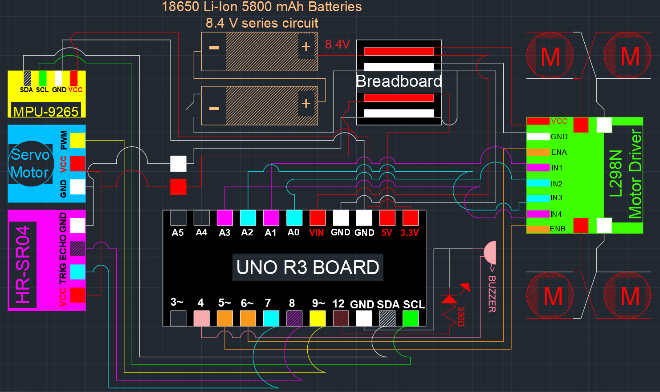In this section it will be provided a picture containing the schematic for all the connections between all the components in this project. Notice, the provided schematic is not at scale, it is simply a visual representation of the connections made for clarification and documentation purposes.

This picture shows all electrical components used in this project. Pins 3~, A5 and A4 are not used in the project. Also, all pins of the UNO R3 board are not shown in this representation.

In the circuit belonging to the LED, it was used a 330 Ohm transistor, this was done to reduce the current delivered to the LED. The type of LED used usually works with 20 mA while the UNO board delivers 40 mA and around 4.95V through pin 12, this excess of current on over time may likely damage the LED and perhaps even the UNO board. So, to solve this it was needed to determine which resistor to use in order to keep the LED working safely using Ohms Law which states that Voltage (V) = Intensity/ Amps (I) times Resistance (R).

*V = IR*

*R = $\frac{V}{I}$*

*R = $\frac{4.95V}{0.020A}$*

*R = 247.5Ω*

As shown, it was determined that the optimal resistor should be 247.5Ω. However, this resistor is not common, so to keep the LED as protected as possible it was used a 330 Ω resistor.

Cable management:

With regards to the cable management in this project, the cables were color coded, especially for the connections with the motor driver which required many connections. For example, the cables connected with IN2 and IN3 of the motor driver have the same color (blue) since both have the same function which is activating the forward movement of the motors, while the cables connected to IN1 and IN4 are magenta since these activate the reverse movement of the motors. Also, the PWM cables are color coded orange, in this schematic, the only PWM colored different is the one belonging to the servo which is connected is pin ~9, this was done to avoid confusion. Also, the negative cables were generally color coded black- notice in the schematic these are generally white so these could be seen against the background- while the positive were color coded red.

Budget

|  |  |
| --- | --- |
| ITEM | COST |
| Li-Ion Batteries 3.7V 5800 mAh (4) + charger | $9.14 (eBay) |
| UNO R3 Board + USB cable | $10.99 (Amazon) |
| Ultrasonic Sensor | $4.23 (Amazon) |
| L298N Motor Driver | $6.89 (Amazon) |
| IMU 92/65 | $8.49 (Amazon) |
| Bread board | $4.99 (Amazon) |
| Jump wire 120 units pack | $6.98 (Amazon) |
| TOTAL | **$51.71** |

*Note: depending on the provider and seller prices may vary.

Special thanks to my cousin Miguel Hernandez for the help organizing the circuit.

Software Section

This section of the report focuses on explaining the procedures and the algorithms used to automate the Autonomous Toy Car (ATC) so that it can avoid obstacles effectively. It explains the control of the motors and the communication with the different sensors. Also, an independent section after this one includes some of the most commons issues with the programming of this project. The programming language used is Arduino, as a result all the libraries used are compatible with this programming language and with the Arduino IDE.

Pin definition and Setup

Before getting started with the program, the first operation done in the code was to define the pins used for this project as well as the same and function of each of these pins. Also, the libraries used in this project were included. Below it could be seen the definition of each of the pins which are numbered and named as well.

#include "SR04.h"

#include <Servo.h>

#include <MPU9250.h>

#define FORWARD_R 14

#define FORWARD_L 16

#define REVERSE_R 15

#define REVERSE_L 17

#define SPEED_R 6

#define SPEED_L 5

#define TRIG_PIN 7

#define ECHO_PIN 8

#define BUZZER 4

#define LED 12

In the definitions above pins 14 and 16 are to control the forward movement of the right and left motors, while pins 15 and 17 control the reverse movement of the right and left motors. The speed of the right and left motors is controlled using pins 6 and 5. Pins 7 and 8 are connected to the Trig and Echo pins on the Ultrasonic sensor.

The next step in the program was to define the mode of the pins either as being output pins or input pins, in this project all pins defined by the user were outputs. Below it is demonstrated the pin mode setup.

pinMode(FORWARD_R, OUTPUT);

pinMode(FORWARD_L, OUTPUT);

pinMode (REVERSE_R, OUTPUT);

pinMode (REVERSE_L, OUTPUT);

pinMode (SPEED_R, OUTPUT);

pinMode (SPEED_L, OUTPUT);

pinMode (LED, OUTPUT);

pinMode (BUZZER, OUTPUT);

Basic Motor Control Functions

In order to control the motors using the L298N motor driver several functions were used to reduce the complexity and length of the program. These functions are very simple and consists of simply setting the previously defined digital pins to either “HIGH” or “LOW” using the digitalWrite() or analogWrite() functions. The digitalWrite function works with digital pins it has two arguments, the name of the pin and the word “HIGH” to enable the pin (output 3.3- 5V depending on the pin) or “LOW” to disable the pin (0V output). The analogWrite function works with PWM pins and it has two arguments, the name of the pin and an integer number from 0- 255 which indicates the average voltage delivered over time in which 0 is none and 255 is the maximum. Below is provided an example of how these functions are used.

analogWrite(SPEED_R, 255);

analogWrite (SPEED_L, 255);

digitalWrite (FORWARD_R, HIGH);

digitalWrite (FORWARD_L, HIGH);

The combinations of these functions as shown above is what makes the toy car move forward, this is used in the moveForward() function in the algorithm. First, the speed of the right and left motors is set to the maximum (255) using the analogWrite function and then the right and left motors are set to move forward using the digitalWrite function. Notice, a common issue in the writing of the program was placing the functions for movement before the functions for speed, this causes to car not to move at all since the speed was not specified the program assumes the speed for the motors is 0. The same functions used for the forward movement are used for the reverse movement of the car in the moveReverse() function, the only difference is that different pin names are used for the digitalWrite functions as shown below.

analogWrite (SPEED_R, 255);

analogWrite (SPEED_L, 255);

digitalWrite (REVERSE_R, HIGH);

digitalWrite (REVERSE_L, HIGH);

In this case when the REVERSE_R and REVERSE_L (pins 15 and 17) are activated, as a result when pins IN1 and IN4 receive voltage these reverse the direction of the current delivered to the motors and thus these now rotate in reverse. Note, a common mistake while writing the reverse and forward movement functions is not disabling the previous pins that where on. For example, if the function moveForward is called and then the moveReverse function this would cause an incongruent movement of the motors. To avoid this the pins FORWARD_R and FORWARD_L need to be disabled. This was done in the algorithm using a function called “halt”, the content of this function is provided below.

analogWrite (SPEED_R, 0);

analogWrite (SPEED_L, 0);

digitalWrite (FORWARD_R, LOW);

digitalWrite (REVERSE_L, LOW);

digitalWrite (FORWARD_L, LOW);

digitalWrite (REVERSE_R, LOW)

Notice, the function halt completely stops the movement of the motors. The speed was also set to zero so that regardless of the independent use of the analogWrite functions outside of the movement function, the movement is stopped. As a result, all movement functions should be first started by setting the speed of both motors to the desired value.

With regards to the left and right turning functions these work similar but use the IMU as reference, so these are covered in a different subsection.

Now, it may be of a little help to explain a bit more on Pulse Width Modulation (PWM) and how it works along with the analogWrite() function. According to the Arduino website, “Pulse Width Modulation is a technique for getting along results with digital means”. The digital means simply consists of turning on (5V) and off (0V) a signal, this creates a square wave between the on and off states of the signal. The time the signal stays in the “on” state is called the pulse width. If the on and off pattern is repeated at high frequency and the time the signal stays on is the same as the time the signal stays off, the result will be a signal with a steady voltage averaging between the on (5V) and off states (0V). So, what really determines the average voltage delivered in the signal is the time of the on and off states of the signal and this time can be manipulated using the analogWrite function. The time the signal stays on which is also called the duty cycle is controlled by writing an integer between 0 and 255 as the second argument of the function analogWrite, as the following picture from the Arduino website shows.

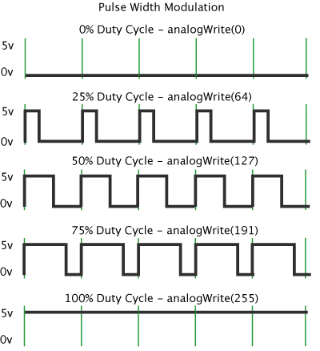

The SPEED_R and SPEED_L (pins 6 and 5) which as previously mentioned are used to control speed through PWM. These two pins are connected to ENA and ENB respectively, the highest the % duty cycle, the greatest the average voltage that will be delivered to the motors by the motor driver and thus the faster these will rotate. Notice, using the value 127 in the analogWrite function for this project to obtain a 50% duty cycle does not means that the speed of the motors will be reduced to exactly 50% or half, this relationship is likely not linear, especially for this prototype because of several factors which may include weight or even the gearing of the motors.

Communicating with the Servo Motor

The communication with the servo motor is very much simply since it works with a library which comes already by default in the Arduino IDE which is called “Servo.h”. For clarification, the communication with the servo is done through PWM, in other words the information of what angle to turn is communicated to the servo by means of PWM pulses. The first step in using this library of course was to include it in the program as shown in the previous subsection. Then the following key word is used to define the name of the servo in the program (this is very helpful when using more than one servo) along with the definition of the variable that will contain the value for the angle which the servo will turn.

Servo looking_angle;

int angle;

The next step was to define to what PWM pin the servo will be connected which is generally don in the setup section. To accomplish this there is a specific function within the Arduino IDE which is demonstrated below.

looking_angle.attach(9);

In the statement shown above we simply tell the program that the servo motor named “looking_angle” is related to the PWM pin number 9 in the UNO R3 board. Now the connection of the UNO board with the servo motor is all set so the next step is simply telling the servo what angle to turn. This is done using the following function.

angle = 93;

looking_angle.write(angle);

In the second statement above the value of the function angle (93) is the indicated value of the angle which will be sent to the servo. Also, it could be simply written the numerical value inside the parenthesis instead of the variable angle. However, in this project it was made the variable angle since it is easier to control the value of a variable and easier to write angle than the whole function. This could be depicted in the algorithm used in this project which makes the servo look right and left, as is provided below.

angle = 93;

for (int i = 0; i < 10 ; i++)

{

angle -= (80 / 10);

looking_angle.write(angle);

(Here the ultrasonic sensor will measure distance)

}

angle = 93;

looking_angle.write(angle);

for (int i = 0; i < 10 ; i++)

{

angle += (80 / 10);

looking_angle.write(angle);

(Here the ultrasonic sensor will measure distance)

}

The program shown above is used to make the servo look towards the right side of the car and then towards the left side of the car at a rate of (80/10) or simply 8 degrees so that the ultrasonic sensor measures the distance after each 8-degree rotation made by the servo, more details about this will be provided in the ultrasonic sensor subsection. Notice, the number 93 is the center angle of the servo, which makes the servo and the ultrasonic sensor attached to it face in the same direction as the car. Also notice, the smallest angle the servo can make is zero degrees and the greatest is 180 degrees. In this project the servo is never taken to its extreme angles to avoid the gears which are made of plastic from getting damaged.

Communicating with the Ultrasonic Sensor

Just like the communication with the servo motor, the communication with the Ultrasonic sensor thanks to the library used which is named “SR04.h” provided by Elegoo corporation. As shown above on the pin definition subsection the TRIG_PIN and ECHO_PIN (pins 7 and 8) are not defined as either being inputs or outputs using the pinMode function. This is because the library does this job when the function SR04() -which is generally called after the pin definition at the start of the program- with the arguments ECHO_PIN and TRIG_PIN as it is shown below.

SR04 sr04 = SR04 (ECHO_PIN, TRIG_PIN);

Then, this function, using the library sets the ECHO_PIN as in input and the TRIG_PIN as output. For clarification purposes, as mentioned in the Electrical section on the subsection about the ultrasonic sensor, using the TRIG_PIN a function within the library will activate this pin for 10 microseconds to send an electric pulse to the ultrasonic sensor. This will generate 8 bursts of 40KHz ultrasonic waves and will activate the timer within the ultrasonic sensor which will measure the time the soundwaves are on the air (propagation time) until these come back. Then this time in microseconds is sent to the UNO board through the ECHO_PIN and a function will convert this propagation time into centimeters using the speed of sound within a function called MicrosecondsToCentimeter(long duration).

After the ECHO_PIN and TRIG_PIN are set as the arguments of the SR04() function, the next step was to create a variable which it could be worked with to store the value of the distance calculated using the sensor and the library. After this is done the function SR04.Distance() is ready to be called to obtain a value of distance as shown below. Note, the library used will return a value for distance every 25 milliseconds approximately.

long distance; // could also be set as a float

distance = sr04.Distance();

This is basically all that was needed to do thanks this library. Now the variable distance could be used to make any modifications, be compared using if statements or being modified. In the Obstacle Avoidance algorithm, the value of “distance” is compared with a value in centimeters in an if statement, allowing the algorithm to decide when it is too close to an obstacle. Furthermore, this library used for the ultrasonic sensor has another function which returns the average distance detected at certain instant of time this function could be called by simply typing sr04.DistanceAvg() instead of sr04.Distance(). However, there is a draw back of using the average distance function and it is that the data rate of the distance value is greatly reduced. As mentioned in the previous subsection it is now provided the full algorithm using the distance sensor to determine the average distance at each side of the car using the SR04 sensor as follows.

float look_right (int data_points, float *turn_angle) {

int i;

float average_right_distance = 0,

total_distance = 0, distance, max_distance = 0;

for (i = 0; i < data_points; i++)

{

angle -= (80 / data_points);

looking_angle.write(angle);

total_distance += sr04.Distance();

distance = sr04.Distance();

if (distance > max_distance and distance < 2100)

{

max_distance = distance;

*turn_angle = angle;

}

}

average_right_distance = total_distance / (float) data_points;

angle = 93;

looking_angle.write(angle);

return average_right_distance;

}

The function above has as arguments an integer called data_points which stands for the number of measurements of distance that will be made when the servo looks at the left and at the right. Notice, the pointer variable *turn_angle is not used in the Obstacle Avoidance Algorithm, but it is intended to store the angle value at which the greatest distance was measured for future use. Within the for loop, the servo motor will turn 80 degrees at a rate of 80 divided by the amount of data points desired, in this case 8 degrees. Then the summation of all 10 distances detected by the ultrasonic sensor using the function sr04.Distance() was stored in the variable total_distace. Finally, after all 10 data points are taken, the for loop will end, the servo will be set to the forward-looking angle (93 degrees) and the average distance at the right will be calculated by dividing total_distance by the amount of data (data_points). The same applies for the left side, just that the servo will add the 8 degrees changing rate (angle += (80 / data_points)).

Communicating with the IMU Sensor

Like the previous components, in this project it is used a library Inertial Measurement Unit MPU 9265, it is called “MPU9250.h” and it was made by Brian R. Taylor at Bolder Flight Systems in 2017 and was available for free in GitHub. Having a library for this component was helpful however, using the data provided by the sensor became a little difficult due to noise in the data, more about this will be discussed at the end of this subsection. The process of communicating with this sensor is a bit more complex than the previous components, however it is not that complicated after all. Notice, this component is connected to the UNO R3 board through the SDA and SCL pins. According to [Circuit Basics](http://www.circuitbasics.com/basics-of-the-i2c-communication-protocol/) SDA is the Serial Data, through this pin information is sent and received, SCL is the Serial Clock which carries the clock signal. SDA and SCL both belong to I2C which is a serial communication protocol for data to be transferred bit by bit along a single wire (SDA line).

The first step for communicating with the IMU sensor was of course including the library named “MPU9250.h” which was previously done in the Pin Definition and Setup subsection. The second step was to define the connection to the MPU-9250 sensor on the I2C bus 0 with address 0x64, and then declare an integer variable names status as shown below.

MPU9250 IMU(Wire,0x68);

int status;

After this step, the communication with the IMU can be started. The author of this library sets the variable “status” to the begin function of the IMU to check weather the sensor initialized correctly or not. I the sensor is initialized incorrectly the program prints “IMU initialization unsuccessful” as it is shown below.

status = IMU.begin();

if (status < 0) {

Serial.println("IMU initialization unsuccessful");

Serial.println ("Check IMU wiring or try cycling power");

Serial.print("Status: ");

Serial.println (status);

while(1) {} // Here it will stay in an infinite loop doing nothing.

}

The next step followed by the author and thus also followed in this project was setting the ranges for the accelerometer -which was set to 4G in this project specifically-, the gyroscope -which was set to 500 DPS in this project specifically- the bandwidth for the Digital Low Pass Filter whose purpose according to [Ulrich Buschbaum](https://ulrichbuschbaum.wordpress.com/2015/01/18/using-the-mpu6050s-dlpf/) is to remove noise from the signal of the sensor and finally the SRD which defines the data update rate- set to 19 for a 50 Hz update rate as done by the author-, all as shown below using the highlighted functions.

IMU.setAccelRange(MPU9250::ACCEL_RANGE_4G); // Setting the accelerometer to 4G

IMU.setGyroRange(MPU9250::GYRO_RANGE_500DPS); // Setting the gyroscope to 500 DPS

IMU.setDlpfBandwidth(MPU9250::DLPF_BANDWIDTH_20HZ); //DLPF bandwidth set to 20 Hz

IMU.setSrd(19); // Setting SRD to 19 which stands for 50 Hz update rate

As shown above the acceleration range used was 4G (4 x gravity) this means that the sensor will be able to precisely detect any acceleration value between -4 and 4 G’s. Also, the gyroscope range was set to a maximum of 500 degrees per second, this means that the gyroscope will precisely detect any variation on rotational velocity in the range between -500 and 500 degrees per second. The DLPF bandwidth was left by default at 20 Hz as done by the author as well as the SRD which was set to 19.

After the previous step was completed, the sensor is ready to be read, the information the sensor can provide for the accelerometer, gyroscope and magnetometer can be used obtained for the *x, y* and *z* axis independently. Furthermore, it even allows to get temperature readings. The functions for getting all this information are shown below.

IMU.getAccelX_mss();

IMU.getAccelY_mss();

IMU.getAccelZ_mss();

IMU.getGyroX_rads();

IMU.getGyroY_rads();

IMU.getGyroZ_rads();

IMU.getMagX_uT();

IMU.getMagY_uT();

IMU.getMagZ_uT();

IMU.getTemperature_C();

Notice, the magnetometer and temperature readings from this sensor were not used in the project due to very unprecise and inconsistent readings. For example, of the IMU module is put close to a metal or a magnet (motors used for this car project), then this alters the readings from the sensor. Also, the temperature sensor was off by around 5 – 7 Celsius degrees.

Noise reduction for the gyroscope and accelerometer data:

Data being retrieved from the gyroscope feature in degrees per second was very accurate, being the gyroscope, the most accurate feature provided by this sensor module. Nevertheless, the accuracy for the accelerometer feature was not very accurate and special procedures needed to get done to eliminate the noise in the data from the sensor. Now, for clarification purposes, in this project the gyroscope data belonging to the *z*-axis was used for the turning algorithm while the acceleration data from the *x*- axis was intended to be used for calculating speed. Below it is shown the data retrieved for the gyroscope (*z*-axis) and accelerometer (*x*- axis).

Notice, the data retrieved was under the settings previously defined. The rate of data update was every 5 milliseconds. This graph was done in Excel.

Notice, the data retrieved was under the settings previously defined. The rate of data update was every 5 milliseconds. This graph was done in Excel.

While the data from the gyroscope ranges from -0.0015 – 0.0015 degrees per second, the data from the accelerometer ranges from around 0.06 to 0.12 m/s^2, indicating a tendency above 0 m/s^2. This eventually became one of the problems while trying to integrate to obtain velocity. To refine this data from acceleration it was needed to calculate the average between all those data points and subtract it from the actual values detected by the sensor, the result after repeating this operation twice is shown in the graph below.

As it is shown the noise from the accelerometer readings was reduced and the values for the acceleration in the *x*-axis were set closer to the target value (0 m/s^2) by subtracting the average value of error 0.09856586.

Problems with integration of data from accelerometer (Program frequency):

Even after the data retrieved from the accelerometer was made more precise in order to perform integration still the error adds up and the velocity calculated increases even when the car is not moving as shown in the data provided below. Furthermore, there was another possible critical issue that made it very difficult to integrate acceleration to obtain the speed at which the car was moving. This issue is the rate at which the data was being retrieved from the sensor in relation with the frequency of the loop used in the Obstacle Avoidance Algorithm as well as the use of a function called “delay()” within the program. To explain, the data from acceleration was needed to be taken constantly especially at the start of the movement of the toy car to integrate it and obtain a true value for velocity before the car’s acceleration became zero.

15:00:36.943 -> Acceleration is --> 0.038670

15:00:36.977 -> Velocity is --> 0.207998

15:00:36.977 -> Acceleration is --> 0.053036

15:00:37.010 -> Velocity is --> 0.616874

15:00:37.043 -> Acceleration is --> 0.029093

15:00:37.078 -> Velocity is --> 0.936875

15:00:37.111 -> Acceleration is --> 0.047050

15:00:37.154 -> Velocity is --> 1.422744

15:00:37.154 -> Acceleration is --> 0.044656

15:00:37.200 -> Velocity is --> 1.894429

15:00:37.247 -> Acceleration is --> 0.054233

15:00:37.247 -> Velocity is --> 2.409876

15:00:37.294 -> Acceleration is --> 0.021910

15:00:37.294 -> Velocity is --> 2.736501

15:00:37.341 -> Acceleration is --> 0.038670

15:00:37.388 -> Velocity is --> 3.119567

15:00:37.388 -> Acceleration is --> 0.037473

15:00:37.435 -> Velocity is --> 3.547921

15:00:37.435 -> Acceleration is --> 0.043459

15:00:37.468 -> Velocity is --> 4.012367

15:00:37.508 -> Acceleration is --> 0.037473

15:00:37.555 -> Velocity is --> 4.434215

15:00:37.555 -> Acceleration is --> 0.042262

15:00:37.602 -> Velocity is --> 4.874976

15:00:37.602 -> Acceleration is --> 0.033882

15:00:37.649 -> Velocity is --> 5.233407

15:00:37.696 -> Acceleration is --> 0.047050

15:00:37.696 -> Velocity is --> 5.719314

Notice, the small error in the acceleration readings adds up when being integrated causing velocity to increase even though this information was retrieved while the car was not moving. Also, with regards to the time lapse between each reading of the acceleration, it happens at a rate of around every 59 milliseconds (Note the time stamp), at this rate definitely there is data being lost since the sensor is set to give data at 50 Hz or every 20 milliseconds and the loop of this algorithm is reading the sensor every 59 milliseconds in average as a result, precision is being lost. Consequently, the integration performed didn’t worked well.

Turning Algorithm

Despite the readings from the accelerometer were not very precise, in the other hand the readings from the gyroscope were indeed very precise and allowed for the implementation of a turning system which uses the angular velocity (degrees per second) given by the gyroscope and integrates it to find the angle which the car have turned. Below it is provided the function made which allows the car to turn a specified number of degrees.

void turn_left (float angle)

{

int activator = 0;

unsigned long start_time, end_time, lapse_time;

float radial_velocity, end_angle = 0, average_calibration;

float turn_to_angle = angle;

analogWrite(SPEED_R, 255);

analogWrite(SPEED_L, 255);

digitalWrite(FORWARD_R, HIGH);

digitalWrite(REVERSE_L, HIGH);

start_time = micros();

while(end_angle < (turn_to_angle) and activator == 0)

{

IMU.readSensor();

end_time = micros();

lapse_time = end_time - start_time;

start_time = end_time;

radial_velocity = - IMU.getGyroZ_rads();

end_angle += (radial_velocity * (lapse_time / 1000000.0))*(180.0/PI);

if (end_angle >= turn_to_angle)

{

halt();

activator = 1;

}

}

digitalWrite(LED, HIGH);

digitalWrite(BUZZER, LOW);

delay(250); // Approximately the sliding time

digitalWrite(LED, LOW);

}

In the turn_left function first of course the variables used within the function are defined, in which the variable end_angle (final angle after turning) is assigned 0 and the turn_to_angle variable is assigned the only argument of the function (float angle) times negative 1 since turning to the left produces a negative angle. Then at full speed (255) the motors for the right side are given power to move forward while the motors at the left are given power to move in reverse, this will make the car turn left. After this was done, the start_time variable was assigned to a function called micros() which returns the number of microseconds that have passed since the program started. Then, a while statement is run under the condition that the end_angle variable (end position of the car in degrees) is less than turn_to_angle (the desired position in degrees). Note is sentinel control variable to make sure the program comes out of the loop at the desired moment. Next, the IMU sensor is read, the program calculates the variation in time (lapse_time) and the angular velocity is integrated. Finally, an if statement will make sure that both variables end_angle have reached the desired value, it will activate the sentinel variable and finalize the movement of the motors. Notice the function delay(250) is used with the purpose of letting the car slide for 250 milliseconds before proceeding with the rest of the program.

Obstacle Avoidance Algorithm

The Obstacle Avoidance Algorithm is the essence of this project and indeed it is very simple (only 50 lines of code), the logic behind it is not complicated. After all variables and pins have been declared as well as the functions for movement, turning and looking have been set and the setup for the sensors and servo have been done, the following loop runs the Obstacle Avoidance Algorithm.

void loop(){

moveForward(255);

IMU.readSensor();

float turn_angle = 0;

distance = sr04.Distance();

angle = 93;

looking_angle.write(angle);

digitalWrite(LED, LOW);

if (distance >= 500)

{

while(distance >= 500)

{

turn_right(5);

distance = sr04.Distance();

}

}

if (distance <= 60)

{

moveForward(80);

digitalWrite(BUZZER, HIGH);

digitalWrite(LED, HIGH);

average_right_distance = look_right(10, &turn_angle);

average_left_distance = look_left(10, &turn_angle);

digitalWrite(BUZZER,LOW);

if (average_right_distance > average_left_distance)

{

halt();

turn_right(45);

}

if (average_left_distance > average_right_distance)

{

halt();

turn_left(45);

}

}

}

As it could be seen above this algorithm simply consists of checking the distance in the surrounding of the car. If an obstacle is detected to be 60 centimeters or less from the car, the car will stop, the servo will look towards the right and left side of the car and will as the ultrasonic sensor which is attached on top gets the distance at each side. The function look_left and look_right will return the average distance collected on each side and based on which average is greater the car will turn right or left 45 degrees. Furthermore, while the reading from the ultrasonic sensor is greater than or equal to 500 centimeters which is beyond what the ultrasonic sensor can measure accurately, the car will turn right by 5 degrees and will recalculate the distance.

Especial credit and thanks to my cousin Miguel Hernandez (Biomedical Engineer) for the assistance provided while writing this algorithm and using the IMU sensor.

Common Issues

Some of the common issues faced while making this project mainly relate to the sensors, especially to the management and use of data. These are covered below for the Ultrasonic and IMU sensors independently.

Ultrasonic sensor issues:

One of the most common issues of using the ultrasonic sensor to measure distance is that it measures false data very often. For example, if there is a wall at around a 50-degree angle from the direction the sound is traveling then, the sound waves bounce on that angled surface and never come back to the sensor. As a result, the sensor generally reports over 2100 cm every time this happens. Thanks to the consistency of these readings every time the sound waves do not return this issue was corrected using the while (distance >= 500) statement in the Obstacle Avoidance Algorithm. Nevertheless, when the car is in tight spaces and the sound bounces away on an angled surface but then it bounces back onto another surface and back to the angled surface it results in the sensor reporting a false reading for distance. An example of this case is pictured below.

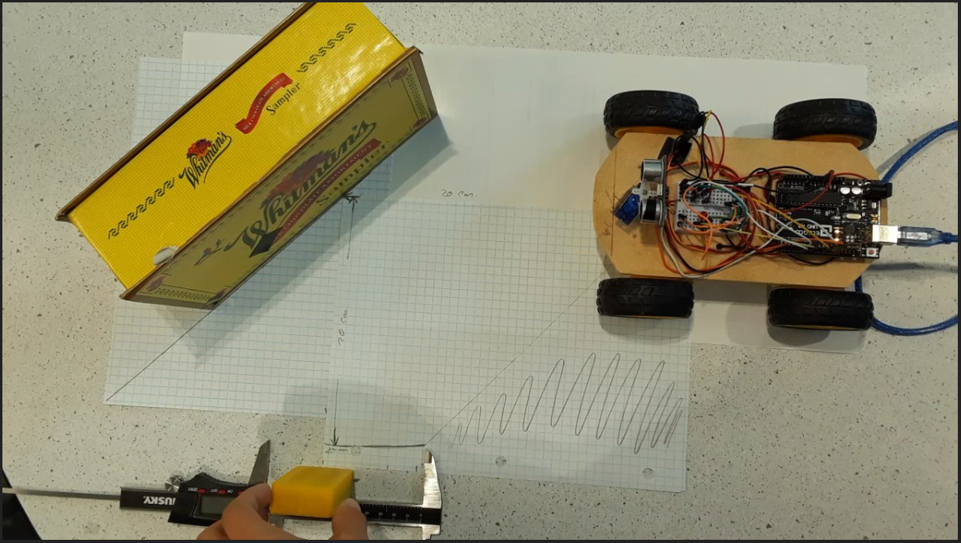In the picture above, the sound wave bounces on the “Whitman’s” yellow box and interacts with any object in the rage marked by the measuring tool depicted. For example, the yellow obstacle being held within this range was detected to be 40 cm away. However, the angled obstacle (the “Whitman’s yellow box) was not detected at all. So, if the car were to be moving towards this obstacle and there is no other obstacle within the detection range, the car will end up crashing with the box. Notice, the toy car depicted was the first prototype of this project.

IMU sensor issues:

As previously mentioned on the section about the IMU, one of the greatest issues with using this sensor is the effective reduction of noise in the data. Even after the noise was removed from the data, if the car was moved to a different orientation the average subtracted to reduce the noise (error) was not as effective removing the noise in the data for this new orientation. Consequently, due to this inaccurate measurement and to the inability to reduce the noise, the integration of this acceleration data resulted to be very unprecise. One way improving this issue is to simply buy a better sensor which provides more accurate data as suggested by my cousin Arian Hernandez (Computer Engineer). A possible option could be the BNO055 sensor module for the UNO R3 board, it’s a sensor four times more expensive than the one used in this project, but certainly for some reason. A picture of this sensor module made by Adafruit corporation is provided below for informative and documentation purposes.

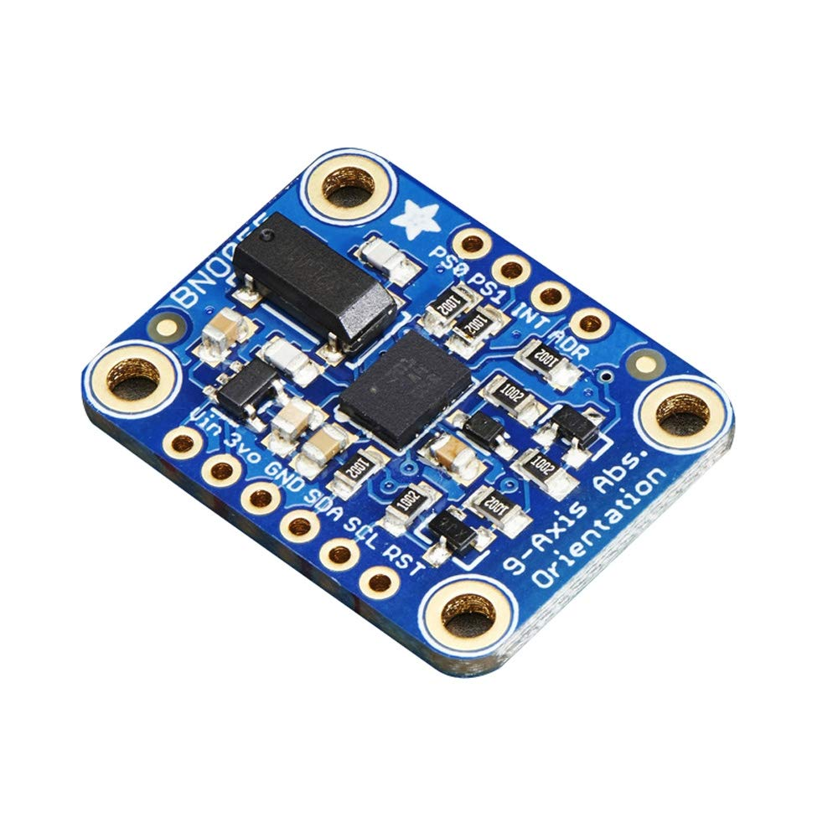

Special thanks to my cousin Arian Hernandez for this recommendation.

Future Improvements

Between some of the future improvements for this project it could be listed of course the use of better sensors like the BNO055 for instance. As of now, this second prototype for the Autonomous Toy Car (ATC 2) can avoid most obstacles. However, if it gets stuck with some low obstacle on the way which is not detected with the Ultrasonic sensor, it never knows that it got stuck. The idea to solve this was to constantly, as the program runs have a reference to the car velocity, that way if the motors are on and the velocity is close to zero the program can assume the car got stuck and take some course of action like doing reverse, for example. Also, some future improvements for this prototype will include a lighter car base made from 3D printed plastic and the use of a Nano board instead of the UNO R3 board. Furthermore, new and lighter batteries rated at 9900 mAh could be used in future improvements of this prototype.

Conclusions

This semester project was very interesting, in doing this project I learned a lot about electronics, 3D design and automation. The process of automating the toy car to avoid obstacles was all a challenge, and still there are future improvements on the way. One very interesting thing in the process of automation was the frequency at which each component operates, especially the sensors. The programming section was crucial in this project many of the errors and inconvenient regarding the calibration of the toy car using other algorithms was fully corrected using the software, thing that was very convenient. Even though the Autonomous Toy Car as a second prototype can avoid most obstacles, there are still bugs that need to be corrected, more problems to be solved and better technologies and algorithms to be implemented to achieve a fully autonomous vehicle.

At this point, if you have read this 50-page report you may wonder why a 2nd year college student at Miami Dade College like me used so much time in not just doing this report but also building an autonomous toy car from scratch since this was not for credit or even for some monetary compensation. The reason is simple; to find some logic application of what I am being taught at school, so that I raise my interest to keep learning, so that what I learn in school does not become so monotonous, and to answer the common questions of many students in STEM classes specially in math courses: “What is the use of all this that I am being taught?”. Thank you for reading!

Acknowledgements

I would like to take a page of this report to acknowledge the individuals and institutions that helped mi in some little way or another to make this project possible. Thank you:

Miguel Hernandez

Eriel Valdes

Diego Padua

Elodie Billionniere

Arian Hernandez

Giorgio Corrado

Jorge Suriel

Kevin Moreno

Ganna Nicol

Chun Heng Sham

Anthony Aguilera

Christopher Garcia

Daniel Morales

Miami Dade College Makers Lab